3GPP TR 22.839 V18.1.0 (2021-12)

Technical Report

3rd Generation Partnership Project;

Technical Specification Group Services and System Aspects;

Study on Vehicle-Mounted Relays;

Stage 1

(Release 18)

** 

The present document has been developed within the 3rd Generation Partnership Project (3GPP TM) and may be further elaborated for the purposes of 3GPP.  
The present document has not been subject to any approval process by the 3GPPOrganizational Partners and shall not be implemented.  
This Report is provided for future development work within 3GPPonly. The Organizational Partners accept no liability for any use of this Specification.  
Specifications and Reports for implementation of the 3GPP TM system should be obtained via the 3GPP Organizational Partners' Publications Offices.

Keywords

<keyword[, keyword]>

***3GPP***

Postal address

3GPP support office address

650 Route des Lucioles - Sophia Antipolis

Valbonne - FRANCE

Tel.: +33 4 92 94 42 00 Fax: +33 4 93 65 47 16

Internet

http://www.3gpp.org

***Copyright Notification***

No part may be reproduced except as authorized by written permission.  
The copyright and the foregoing restriction extend to reproduction in all media.

© 2021, 3GPP Organizational Partners (ARIB, ATIS, CCSA, ETSI, TSDSI, TTA, TTC).

All rights reserved.

UMTS™ is a Trade Mark of ETSI registered for the benefit of its members

3GPP™ is a Trade Mark of ETSI registered for the benefit of its Members and of the 3GPP Organizational Partners  
LTE™ is a Trade Mark of ETSI registered for the benefit of its Members and of the 3GPP Organizational Partners

GSM® and the GSM logo are registered and owned by the GSM Association

Contents

Foreword 7

1 Scope 8

2 References 8

3 Definitions and abbreviations 8

3.1 Definitions 8

3.2 Abbreviations 8

4 Overview 9

5 Use cases 10

5.1 Basic support, configuration and control of mobile relays 10

5.1.1 Description 10

5.1.2 Pre-conditions 10

5.1.3 Service Flows 10

5.1.4 Post-conditions 11

5.1.5 Existing features partly or fully covering the use case functionality 11

5.1.6 Potential New Requirements needed to support the use case 11

5.2 Authorization and configuration for mobile base station relay 11

5.2.1 Description 11

5.2.2 Pre-conditions 11

5.2.3 Service Flows 12

5.2.4 Post-conditions 12

5.2.5 Existing features partly or fully covering the use case functionality 12

5.2.6 Potential New Requirements needed to support the use case 12

5.3 Multiple working modes of vehicle mounted base station 12

5.3.1 Description 12

5.3.2 Pre-conditions 13

5.3.3 Service Flows 13

5.3.4 Post-conditions 13

5.3.5 Existing features partly or fully covering the use case functionality 13

5.3.6 Potential New Requirements needed to support the use case 14

5.4 Control of UEs access via mobile relays 14

5.4.1 Description 14

5.4.2 Pre-conditions 14

5.4.3 Service Flows 14

5.4.4 Post-conditions 15

5.4.5 Existing features partly or fully covering the use case functionality 15

5.4.6 Potential New Requirements needed to support the use case 15

5.5 Control of UEs access via mobile relays using application-based subscription 15

5.5.1 Description 15

5.5.2 Pre-conditions 16

5.5.3 Service Flows 16

5.5.4 Post-conditions 16

5.5.5 Existing features partly or fully covering the use case functionality 16

5.5.6 Potential New Requirements needed to support the use case 16

5.6 Keep connectivity via mobile base station relay 16

5.6.1 Description 16

5.6.2 Pre-conditions 17

5.6.3 Service Flows 17

5.6.4 Post-conditions 17

5.6.5 Existing features partly or fully covering the use case functionality 17

5.6.6 Potential New Requirements needed to support the use case 17

5.7 Optimizing mobility for UEs 18

5.7.1 Description 18

5.7.2 Pre-conditions 18

5.7.3 Service Flows 18

5.7.4 Post-conditions 19

5.7.5 Existing features partly or fully covering the use case functionality 19

5.7.6 Potential New Requirements needed to support the use case 19

5.8 Load balancing for mobile base station relays 19

5.8.1 Description 19

5.8.2 Pre-conditions 19

5.8.3 Service Flows 20

5.8.4 Post-conditions 20

5.8.5 Existing features partly or fully covering the use case functionality 20

5.8.6 Potential New Requirements needed to support the use case 20

5.9 Provide location service to a UE attached to the relay mounted in the vehicle 21

5.9.1 Description 21

5.9.2 Pre-conditions 21

5.9.3 Service Flows 21

5.9.4 Post-conditions 21

5.9.5 Existing features partly or fully covering the use case functionality 21

5.9.6 Potential New Requirements needed to support the use case 22

5.10 Incentives and charging 22

5.10.1 Description 22

5.10.2 Pre-conditions 22

5.10.3 Service Flows 22

5.10.4 Post-conditions 23

5.10.5 Existing features partly or fully covering the use case functionality 23

5.10.6 Potential New Requirements needed to support the use case 23

5.11 Use cases on Service continuity 23

5.11.1 Mobility between macro and relay 23

5.11.1.1 Use case 1: User entering/leaving the vehicle 23

5.11.1.2 Use case 2: User outside the vehicle 24

5.11.2 Mobility of relay between macro nodes 26

5.11.2.1 Use case 1: User inside the vehicle 26

5.11.2.2 Use case 2: User outside the vehicle 28

5.11.3 Mobility between relays 29

5.11.3.1 Use case 1: User inside the vehicle 29

5.11.3.2 Use case 2: User outside the vehicle 31

5.11.4 Group UEs’ service continuity 32

5.11.4.1 Description 32

5.11.4.2 Pre-conditions 32

5.11.4.3 Service Flows 33

5.11.4.4 Post-conditions 33

5.11.4.5 Existing features partly or fully covering the use case functionality 33

5.11.4.6 Potential New Requirements needed to support the use case 33

5.12 Optimizing UE mobility from planned or predicted mobility information 33

5.12.1 Description 33

5.12.2 Pre-conditions 34

5.12.3 Service Flows 34

5.12.4 Post-conditions 34

5.12.5 Existing features partly or fully covering the use case functionality 35

5.12.6 Potential New Requirement needed to support the use case 35

5.13 Use of mobile relay as secondary node 35

5.13.1 Description 35

5.13.2 Pre-conditions 35

5.13.3 Service Flows 36

5.13.4 Post-conditions 37

5.13.5 Existing features partly or fully covering the use case functionality 37

5.13.6 Potential New Requirements needed to support the use case 37

5.14 Optimized relay for in-vehicle devices 38

5.14.1 Description 38

5.14.2 Pre-conditions 38

5.14.3 Service Flows 38

5.14.4 Post-conditions 39

5.14.5 Existing features partly or fully covering the use case functionality 39

5.14.6 Potential New Requirements needed to support the use case 39

5.16 Non-terrestrial coverage for Mobile Vehicular Relays 41

5.16.1 Description 41

5.16.2 Pre-conditions 41

5.16.3 Service Flows 41

5.16.4 Post-conditions 42

5.16.5 Existing features partly or fully covering the use case functionality 42

5.16.6 Potential New Requirements needed to support the use case 42

5.17 Vehicle Relay sharing 42

5.17.1 Description 42

5.17.2 Pre-conditions 42

5.17.3 Service Flows 43

5.17.4 Post-conditions 43

5.17.5 Existing features partly or fully covering the use case functionality 43

5.17.6 Potential New Requirements needed to support the use case 43

5.18 Monitoring of vehicle-mounted relays 43

5.18.1 Description 43

5.18.2 Pre-conditions 44

5.18.3 Service Flows 44

5.18.4 Post-conditions 44

5.18.5 Existing features partly or fully covering the use case functionality 44

5.18.6 Potential New Requirements needed to support the use case 44

5.19 Simultaneous connectivity via multiple mobile BS relays 45

5.19.1 Description 45

5.19.2 Pre-conditions 45

5.19.3 Service Flows 45

5.19.4 Post-conditions 46

5.19.5 Existing features partly or fully covering the use case functionality 46

5.19.6 Potential New Requirements needed to support the use case 46

5.20 Using a partner 5G network to transport vehicle relay traffic 46

5.20.1 Description 46

5.20.2 Pre-conditions 47

5.20.3 Service Flows 47

5.20.4 Post-conditions 47

5.20.5 Existing features partly or fully covering the use case functionality 47

5.20.6 Potential New Requirements needed to support the use case 48

5.21 Improved connectivity based on the relay mobility pattern 48

5.21.1 Description 48

5.21.2 Pre-conditions 49

5.21.3 Service Flows 49

5.21.4 Post-conditions 49

5.21.5 Existing features partly or fully covering the use case functionality 49

5.21.6 Potential New Requirements needed to support the use case 49

5.22 Mobility between Non-terrestrial coverage and terrestrial coverage for Mobile Vehicular Relays 50

5.22.1 Description 50

5.22.2 Pre-conditions 50

5.22.3 Service Flows 50

5.22.4 Post-conditions 51

5.22.5 Existing features partly or fully covering the use case functionality 51

5.22.6 Potential New Requirements needed to support the use case 51

5.23 Mobile Vehicular Relays using Non-terrestrial and terrestrial access simultaneously 51

5.23.1 Description 51

5.23.2 Pre-conditions 51

5.23.3 Service Flows 51

5.23.4 Post-conditions 52

5.23.5 Existing features partly or fully covering the use case functionality 52

5.23.6 Potential New Requirements needed to support the use case 52

6 Other considerations 53

7 Potential Consolidated Requirements 53

7.0 Introduction 53

7.1 General requirements 55

7.2 Multi-link connectivity 56

7.3 Mobility 56

7.4 Charging 56

7.5 Other aspects 57

8 Conclusions and Recommendations 57

# Foreword

This Technical Report has been produced by the 3rd Generation Partnership Project (3GPP).

The contents of the present document are subject to continuing work within the TSG and may change following formal TSG approval. Should the TSG modify the contents of the present document, it will be re-released by the TSG with an identifying change of release date and an increase in version number as follows:

Version x.y.z

where:

x the first digit:

1 presented to TSG for information;

2 presented to TSG for approval;

3 or greater indicates TSG approved document under change control.

y the second digit is incremented for all changes of substance, i.e. technical enhancements, corrections, updates, etc.

z the third digit is incremented when editorial only changes have been incorporated in the document.

# 1 Scope

The present document is the outcome of the study on use cases and potential new requirements for 5GS support of mobile base station relays mounted on vehicles, using 5G NR over the radio links toward UEs and macro RAN (connected to 5GC). This study covers aspects related to:

* Vehicle base station relays providing service to UEs inside the vehicle or in the vicinity of the vehicle;
* End-to-end service continuity during mobility scenarios (including mobility of the relays);
* Provisioning, policies and control, e.g. for
  + Provisioning of spectrum used by the relays, geographic area restrictions;
  + Control of relay operation, UEs access and connectivity via relays.
* Aspects related to roaming of relays, security, regulatory requirements (e.g. for emergency services), charging, spectrum interference.
* Gap analysis between the identified requirements and existing 5GS requirements or functionalities.

# 2 References

The following documents contain provisions which, through reference in this text, constitute provisions of the present document.

- References are either specific (identified by date of publication, edition number, version number, etc.) or non‑specific.

- For a specific reference, subsequent revisions do not apply.

- For a non-specific reference, the latest version applies. In the case of a reference to a 3GPP document (including a GSM document), a non-specific reference implicitly refers to the latest version of that document *in the same Release as the present document*.

[1] 3GPP TR 21.905: "Vocabulary for 3GPP Specifications".

[2] 3GPP TR 38.821: “Solutions for NR to support non-terrestrial networks (NTN)”

# 3 Definitions and abbreviations

## 3.1 Definitions

For the purposes of the present document, the terms and definitions given in 3GPP TR 21.905 [1] and the following apply. A term defined in the present document takes precedence over the definition of the same term, if any, in 3GPP TR 21.905 [1].

**example:** text used to clarify abstract rules by applying them literally.

## 3.2 Abbreviations

For the purposes of the present document, the abbreviations given in 3GPP TR 21.905 [1] and the following apply. An abbreviation defined in the present document takes precedence over the definition of the same abbreviation, if any, in 3GPP TR 21.905 [1].

<ACRONYM> <Explanation>

# 4 Overview

Demand for improved 5G cellular coverage and connectivity continues to increase, which may be challenging in many outdoor and mobility scenarios. In some outdoor environments, the availability of vehicles equipped with mobile base station relays, either following a certain known/predictable itinerary (e.g. buses, trams, etc), or situated in convenient locations (e.g. outside stadiums, hot-spot areas, or emergency sites), could provide very opportunistic boost to cellular coverage and capacity when/where needed. Those relays, using 5G wireless backhaul toward the macro network, could indeed offer better 5G coverage and connectivity to neighbouring UEs. Vehicle relays are obviously very suitable also for improving connectivity for users or devices inside the vehicle itself, in different environments, e.g. for passengers in buses, car/taxi, or trains, ad-hoc/professional personnel or equipment. Yet other target scenarios are where vehicle relays can be used for reaching users or devices that would otherwise have no or very poor macro coverage, e.g. in case of first responders dislocated in indoor buildings/areas, using 5G relays placed on their nearby/outside vehicles to get required 5G coverage and connectivity.  
The technical benefits of using vehicle relays include, among others, the ability of the BS relay to get better macro coverage than a nearby UE, e.g exploiting better RF/antenna and power capabilities. Besides the value for network operators and end users, worthy incentives could be found for other parties as well, e.g. for vehicles manufacturers, vehicle/fleet owners or providers, to install and operate relays in their vehicles.

In the context of this TR, from a high-level 5G system point of view, the target scenarios include moving vehicles equipped with small on board base station (BS) relays providing 5G coverage and communication to UEs (inside the vehicle and/or in its vicinity), and connected wirelessly to the 5G network via RAN (donor) nodes.

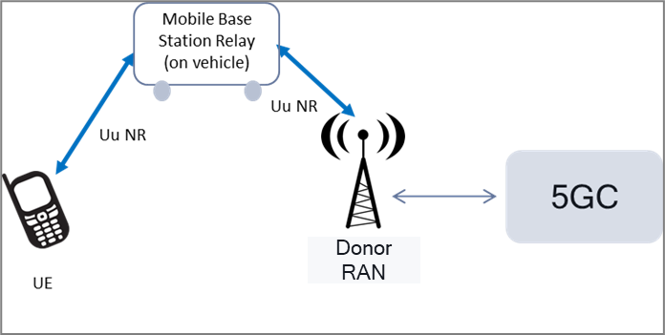

Figure 4-1. Mobile base station relay - High level concept

As shown in the figure above, the main connectivity assumptions are:

* 5G NR is used for the radio link between mobile BS relay and donor RAN node, as well as the radio link between BS relay and UE.
* The mobile BS relay connects, via donor RAN node, to the 5G Core network (5GC).
* Single-hop relay is the main/baseline scenario (multi-hop can be a possible option)

The study intends to cover use cases of BS relays mounted on ground/land type of mobile vehicles; nevertheless, some potential requirements may be general (for a “mobile base station relay”), i.e. could apply to BS relays mounted on different types of moving vehicles or devices.

NOTE 1: the above (logical) diagram and assumptions do not intend to limit nor preclude specific RAN and relay architecture, or topology options.

NOTE 2: While the identified new service requirements target potential 5G system (UE and/or NW) enhancements, this should not prevent support (also) for legacy UEs.

In the paragraphs that follow, next section (sec. 5) captures several identified use cases and new potential requirements, covering (among others): basic operation of vehicle relays, relay configuration, UE access control, optimized connectivity and mobility, load balancing, support of location services, QoS and charging, service continuity during mobility (between relay and macro, or among relays or when macro node changes), multi-connectivity, ad-hoc coverage and topologies (e.g. for public safety), RAN/relay sharing, satellite backhauling.  
In addition to those, section 6 covers further aspects and requirements, e.g. about support of roaming, regulatory requirements, emergency services, security, priority services.

The two concluding sections (sec. 7 and 8) contain the list of consolidated new potential requirements, from all use cases, and the final TR recommendations.

# 5 Use cases

## 5.1 Basic support, configuration and control of mobile relays

### 5.1.1 Description

It’s almost summertime, and a series of outdoor festivals and events are planned in town, for the next weeks/months. This is known to attract many people and tourists, using public/private transportation (bus, taxi) to travel from/to airport and move around the city, as well as attending various shows and events scheduled in different city parks, stadiums and other outdoor areas. 5G traffic demand will be very high and challenging.

The city administration and few partner companies provide transportation services with various buses/taxis inside the city, as well as shuttles between the airport (located outside the city area) and hotels. In addition, one of the partner companies provides small vehicles/carts used to display marketing/advertisement messages/banners, that can be deployed to drive/transit inside parks, around stadiums or recreational/tourist areas.

Those vehicles are (or can be) equipped with 5G mobile BS relays for inside/outside users and, upon request and/or specific commercial agreements, can be used and configurable by MNOs to interconnect and operate as part of their 5G RAN.

### 5.1.2 Pre-conditions

Operator A, with existing 5G macro coverage in/around the city, decides to acquire the service offered by the transport administration and use some of those vehicle relays, in particular:

- advertisement carts, to extend challenging macro 5G coverage and capacity for outdoor users in hot-spot locations where city’s events or high-density gatherings are expected.

- buses and taxis, to provide a better 5G in-vehicle experience to its subscribers (or inbound roamers), as well as improving the overall RAN capacity in certain challenging macro areas, e.g. along the highway to the airport, and/or macro cells serving popular bus/taxi locations/routes in the city.

### 5.1.3 Service Flows

1. Operator A enables the vehicle relays to operate and interconnect with its 5G macro RAN and network.
2. Operator A configures initial relays operating parameters and conditions, e.g. in terms of radio spectrum, vehicles location/itinerary, time of the day, transit/stop in target areas, vehicle speed, etc.
3. On a certain day, prior to the events season, Operator A activates the relays.
4. 5G traffic starts flowing through all activated vehicle relays. Operator A can re-configure some of the relay operating parameters (e,g, spectrum, time/location of operation) based on observed 5G traffic and RAN performance.
5. Toward the end of the summer, based on lower 5G traffic demand, Operator A decides to deactivate relay operation (on its network) for the advertisement carts and few of the city taxis. Service on city buses and shuttles from/to airport is continued.

Note: in some of the actions above, there may also be involvement of a 3rd party entity (e.g. vehicle or relay manufacturer/owner, or relay O&M company), to allow or help the operator A to (de)activate and/or configure certain relay settings.

### 5.1.4 Post-conditions

The operator A is very happy about the improved performance of its 5G network during the busy city summer, and the better service provided to its 5G customers.

### 5.1.5 Existing features partly or fully covering the use case functionality

Current stage-1 requirements (e.g. on wireless self-backhaul, in TS 22.261), as well as existing stage-2/3 functionalities and architecture options (e.g. IAB) do not assume or address full relay mobility (e.g. BS relays on board of moving vehicles), thus may not cover the identified new potential requirements, which are intended to be specific to mobile BS relays.

### 5.1.6 Potential New Requirements needed to support the use case

[PR 5.1-1] The 5G system shall support efficient operation of mobile base station relays, e.g. on board of mobile vehicles, connected wirelessly to the NG-RAN and serving nearby 5G NR UEs (inside and/or outside the vehicle).

[PR 5.1-2] The 5G system shall support means, for a mobile network operator, to configure, provision and control the operation of a mobile base station relay, including

* activation and/or deactivation of mobile relay operation;
* configuration of 5G spectrum (licensed or unlicensed) used by the mobile relay, over the radio links toward UE and RAN;
* configuration of relay operating conditions e.g. based on geographic areas or locations, specific time period(s), vehicle’s speed, itinerary, etc.

Note: besides the MNO, a 3rd party entity could also be enabled to provision and control some of the mobile base station relay operation, e.g. (de)activation, location restrictions, or other operating conditions.

## 5.2 Authorization and configuration for mobile base station relay

### 5.2.1 Description

In the urban environment, temporary needs are raised up for extra cellular coverage and connectivity during various social events (e.g., music festival, sport race, etc.) at a designated area, where pertinent QoS cannot be fulfilled for a large amount of users. In this case, vehicles installed with on board base stations may act as relay and help to offer convenient and efficient service to UEs. They can be situated in specific locations (e.g. outside stadiums), and provide 5G coverage to neighbouring UEs outside the vehicles.



Figure 5.2-1: Authorization and configuration for mobile base station relay

### 5.2.2 Pre-conditions

To enable this use, following pre-conditions should be met:

- A car shall be equipped with on-board base station.

- The mobile base station relay is capable of providing 5G connectivity to UEs in the vicinity of the car.

- The mobile base station relay is able to connect the NG-RAN and 5G Core network.

### 5.2.3 Service Flows

1. When the car starts the engine, the mobile base station relay registers to the 5G network and obtains the necessary configuration information (e.g., operating frequency bands). After getting authorized, the mobile base station relay is able to provide 5G access.
2. The car drives into the permitted area, where the mobile base station relay is able to provide 5G access to neighbouring UEs in the vicinity of the cars.
3. UE A is connected to the mobile base station relay when it moves into the permitted area.
4. As the car moves out of the permitted area, the mobile base station relay cannot work anymore and UE A is disconnected.
5. When the car drives into another permitted area, the mobile base station relay works again and UE B is connected.
6. When the car reaches the destination, its engine is turned off and the mobile base station relay stops working automatically.

### 5.2.4 Post-conditions

The authorized UEs in the vicinity of the car are provided with extended 5G connectivity by the mobile base station relay.

### 5.2.5 Existing features partly or fully covering the use case functionality

Current stage-1 requirements (e.g. on wireless self-backhaul, in TS 22.261), as well as existing stage-2/3 functionalities and architecture options (e.g. IAB) do not assume or address full relay mobility (e.g. BS relays on board of moving vehicles), thus may not cover the identified new potential requirements, which are intended to be specific to mobile BS relays.

### 5.2.6 Potential New Requirements needed to support the use case

[PR 5.2-1] The 5G system shall support the use of mobile base station relays (e.g. mounted on vehicles), which can provide 5G access toits authorized UEs in the vicinity.

[PR 5.2-2] The 5G system shall enable the authorization of the mobile base station relays (e.g. mounted on vehicles) to work in a permitted area. When the mobile base station relay moves out of this area, it is not allowed to work as a base station.

[PR 5.2-3] The 5G network can dynamically configure the operation parameters of a mobile base station relay, such as frequency band, permitted geographical area, etc.

## 5.3 Multiple working modes of vehicle mounted base station

### 5.3.1 Description

In order to fulfil the high demand of extra cellular coverage and capacity in large cities with a dense population, either buses or cars with on board base stations, are expected to act as relay and help provide convenient and efficient data delivery service to the city residents.

Generally speaking, car is privately owned and the base station mounted on it usually supports a private working mode, i.e., it only allows individual access to the car owner’s UEs, e.g., his/her family members, friends, etc.

On the contrary, base station mounted on a bus usually works in a public manner. All the passengers in the bus or in the vicinity can access to the base station on the bus along its predictable itinerary regarding their extra 5G cellular access requirements.



Figure 5.3-1: Vehicle mounted base station

### 5.3.2 Pre-conditions

To enable this use, following pre-conditions should be met:

* Alice wants to join a music festival and share the live show to her friend Bob.
* Alice’s car is installed with an on-board base station.
* The bus that Bob takes is also equipped with on board base station along its itinerary.
* In the area around the spot of the music festival, the base station mounted on the vehicle is allowed to provide 5G coverage to neighbouring UEs outside the vehicles.
* Either the base station on a car or bus is able to connect the NG-RAN and 5G Core network.

### 5.3.3 Service Flows

1. Alice drives by her own car to the spot of the music festival with her family. Alice as well as her family’s UEs is connected to the base station on her car, which has been set to provide private access only. Alice pickup her friend Mary at Mary’s home when she drives her car to the fesitval, and Mary’s UE is connected to the base station on Alice’s car since Alice grant Mary to access, e.g. by giving Mary an Token. Mary uses her UE and the Token to access the Internet via the base station on the car during Alice drives.
2. Alice parks her car in a parking lot near the spot of the music festival. John is a stranger in the nearby. His UE tries to connect to the base station on Alice’s car, but it fails without be granted authentication from Alice.
3. At the same time, Bob takes a bus back home, with a base station mounted on it. Bob’s UE is connected to the base station on the bus, which provides public access to all the passengers on the bus.
4. Alice starts sharing video with Bob the live video during the concert festival.
5. At the festival, Alice meets three of her friends. Since long time no see, they decide to go back to Alice’ home for further drinks and chatting. Then Alice set the base station on her car to provide open access. With this setting, all friends on the car can access the Internet via the base station on the car.
6. When Alice arrived at home, she parked her car and turn off the base station on the car. All her friends and Alice then not able to access the base stations on the car.

### 5.3.4 Post-conditions

Alice shares the live video of the music festival to Bob via 5G access from the base station on her car.

Bob is happy to watch a live show via 5G access from the base station on bus.

Mary is happy to access the Internet via the base station on the Alice car during Alice drives.

All friends of Alice are happy to access the Internet via the base station on the Alice car.

### 5.3.5 Existing features partly or fully covering the use case functionality

The mobility management of the vehicle mounted base station shall be taken into account.

Multi-network connectivity and service delivery across operators will be used to assist this use case. The 5G system shall be able to maintain service continuity with minimum service interruption when the serving network is changed to a different serving network operated by a different operator.

### 5.3.6 Potential New Requirements needed to support the use case

[PR 5.3-1] The 5G system shall support the use of vehicle mounted mobile base station relays, which provide 5G access to UEs in the vicinity.

[PR 5.3-2] Subject to operator policy, the 5G system shall support means to configure and enable a vehicle mounted mobile base station relays to allow access to all UEs, or to only allow access to certain authorized UEs e.g., vehicle owner’s family members, friends, etc.

## 5.4 Control of UEs access via mobile relays

### 5.4.1 Description

As part of a nationwide campaign to stimulate and increase use of public transportation, a mobile operator (“Green”) and cities administrations launch a “premium 5G connection” service to be offered to Green subscribers, and tourists from partner roamers, when travelling on public buses, trams, trains and underground in the main cities of the country.   
The improved 5G connectivity would be provided by using 5G mobile base station relays installed on board of public transport vehicles, which inter-connect (wirelessly) to the 5G macro network as part of Green 5G network.

Green decides to offer free and prioritized access to in-vehicle 5G relays to some of their executive customers, while for other Green subscribers (and roamers), access via relays would require and depend on a per-user permission, associated to a certain public transport ticket or membership. The user permission to access the relays may be specific per transport vehicles, and per geographic location/area. In addition, Green can configure other policies and parameters, as part of the RAN and/or relay settings, which may also depend on some macro RAN or other network constraints and conditions, for example it may limit/prioritize access to mobile relays based on time of the day, relay load, speed etc..

### 5.4.2 Pre-conditions

In the service flow below, as an example, the following public transport “city pass” options are assumed to be available, and corresponding relay access permission policies to be set and provisioned by Green:

Note: a city pass can have different time duration/validity (1 - 12 months) and includes free ticket/ride for all public transportation (bus, tram, metro, trains) in all areas, plus other benefits like entrance to city museums, parks etc..

* 1-month city pass: Access to mobile relays on all buses, city centre area only, during non-peak hours
* 6-month city pass: Access to mobile relays on all buses and trams, inside & outside city centre, non-peak hours
* 1-year city pass: Access to mobile relays on all public vehicles (including metro & trains), all city, any time
* “Executive” pass (for Green executives only): Full/unrestricted permission to access mobile 5G relays, nationwide

For executive users, further higher priority access could be configured in case of specific relay or RAN operating/capability conditions, e.g. related to relay load or mobility factors. As example, normal priority UEs may connect via relays on buses only if less than 5 users are active (via the relay) and/or at bus speed is in a certain range, while executive UEs would have unrestricted access/connection in the same conditions.

### 5.4.3 Service Flows

1. Three users, Alice, Bob and Charlie (Green customers) have the following city pass/status

* Alice: Executive;
* Bob: 1-month pass;
* Charlie: 6-months pass

They work for the same company (Green) and same office building, located outside the main city area, and live in the same city centre neighbourhood.

1. Every day they share same itinerary and public transport vehicles to commute between home to work, i.e.
   1. Around 6am (non-peak hour), one bus from home to the tram station (city centre area), then a tram to the office (from inside to outside city centre).
   2. Around 6pm (peak hour), opposite itinerary to return home
2. During their commuting, they typically use their smartphone almost all the time (active 5G connection), to browse internet and/or various social media communication. Based on their city pass/membership and other policies assumed above, they will experience the following 5G access/connectivity situations:
   1. Alice:
      1. Home to office: connected via relay on the bus and the tram
      2. Office to home: same as above, high priority access
   2. Bob:
      1. Home to office: connected via relay on the bus
      2. Office to home: no access via relay
   3. Charlie:
      1. Home to office: connected via relay on the bus and part of the tram itinerary (till city centre limit)
      2. Office to home: partially connected via relay on the bus and the tram (inside city centre);
         * During peak hour, given normal priority rights, sometimes connection via relay on the bus is not possible, e.g. if/when other 5 Green passengers are on the bus and already actively connected via the relay.

### 5.4.4 Post-conditions

All three users enjoy the premium 5G service from Green during their daily commuting to/from office, and are happy about their membership to the 5G-friendly public transport system!

### 5.4.5 Existing features partly or fully covering the use case functionality

Current stage-1 requirements (e.g. on wireless self-backhaul, in TS 22.261), as well as existing stage-2/3 functionalities and architecture options (e.g. IAB) do not assume or address full relay mobility (e.g. BS relays on board of moving vehicles), thus may not cover the identified new potential requirements, which are intended to be specific to mobile BS relays.

### 5.4.6 Potential New Requirements needed to support the use case

[PR 5.4-1] The 5G system shall support provisioning and configuration mechanisms to control UEs’ access to the 5G network via a mobile base station relay, based on

* User/UE subscription and/or permission (can be specific to each preferred relay);
* User/UE or relay geographical location, time of the day, load, speed.

## 5.5 Control of UEs access via mobile relays using application-based subscription

### 5.5.1 Description

A mobile operator (“Blue”) partners with the public transit organization of ConnectedTown to offer 5G connectivity to passengers of public city buses and trams. The 5G connectivity will be provided using 5G base station relays installed on board of those vehicles, connected to the Blue 5G RAN network.

### 5.5.2 Pre-conditions

Blue decides to give its own subscribers free access to 5G connectivity in city buses and trams, and to offer subcribers of other operators the possibility to subscribe to the service for a fee, with the following tariff plans available:

* 20 min access in any bus or tram;
* one day access in any bus or tram;
* one month access in any bus or tram.

### 5.5.3 Service Flows

1. Three users, Jack, Jill and Francois are about to enter a bus equipped with a Blue 5G on board relay

* Jack is a Blue subscriber
* Jill is a Purple subscriber
* Francois is from France and visiting ConnectedTown during his vacation. He is a Rouge (French operator) subscriber

1. When on the bus
   1. Jack’s UE automatically connects to the vehicle relay
   2. Jill and Francois get a notification on the UI of their UE informing them about the availability of in-bus 5G service and listing the corresponding app available for download.
2. Jill, who is commuting to work, recalls that Purple’s coverage on the bus route is usually spotty. Since she rides the bus every weekday to go to work, she downloads the app and decides to sign up for the one month plan. Francois also downloads the app. He is only in town for a day and from the information provided by the app, he determines that the rate offered by Blue is cheaper than what he gets from the preferred VPLMN with which Rouge has a roaming agreement in ConnectedTown, so he signs up for the one day plan. Jill and Francois’ UEs connect to the vehicle relay.

### 5.5.4 Post-conditions

All three users enjoy the 5G connectivity from Blue, and – when leaving the bus - give positive feedback to the driver about the efficient and high-tech public buses.

### 5.5.5 Existing features partly or fully covering the use case functionality

Current stage-1 requirements (e.g. on wireless self-backhaul, in TS 22.261), as well as existing stage-2/3 functionalities and architecture options (e.g. IAB) do not assume or address full relay mobility (e.g. BS relays on board of moving vehicles), thus may not cover the identified new potential requirements, which are intended to be specific to mobile BS relays.

### 5.5.6 Potential New Requirements needed to support the use case

[PR 5.5-1] The 5G system shall support mechanisms to control UEs selection of mobile base station relays and UEs access to the 5G network via a mobile base station relay, based on

* user/UE subscription and/or permission (can be specific to each preferred relay);
* user preference, for manual selection of a specific relay.

## 5.6 Keep connectivity via mobile base station relay

### 5.6.1 Description

In the urban environment, especially during the rush hour, a high density of passengers is waiting at the bus stop, which puts forwards a high demand for 5G area traffic capacity. A fleet of buses with on board base stations act as relays, which are expected to provide an efficient content delivery to these passengers. The buses typically move at a low speed and usually follow a certain predictable itinerary, along which the extra cellular capacity requirements are fulfilled.



Figure 5.6-1: Connectivity maintenance via mobile base station relay

### 5.6.2 Pre-conditions

To enable this use, following pre-conditions should be met:

- A bus shall be equipped with a mobile base station relay.

- The mobile base station relay is capable of providing 5G connectivity to UEs in the bus along the bus itinerary.

- The mobile base station relay is able to connect the NG-RAN and 5G Core network.

### 5.6.3 Service Flows

1. At a bus stop, there are two bus lines and passengers are either waiting for bus A or bus B.
2. Before the bus is arriving, 5 people are waiting at the bus stop, namely #1, #2, #3, #4, #5. All of their UEs are connected to the terrestrial base stations.
3. When bus A arrives, # 1 and #2 get on bus and their UEs access to the mobile base station relay A. Meanwhile, UEs of #3, #4 and #5 are still connected to the terrestrial base station.
4. Bus A leaves the bus stop.
5. During the driving process of bus A, UE #1 and UE #2 remain connected through mobile base station relay A.
6. When bus A arrives at the next bus stop, # 1 gets off the bus A and UE #1 connects to the terrestrial base station. #2 is still on the bus, and UE #2 remains connected through mobile base station relay A.
7. Bus A arrives at the destination, # 2 gets off the bus and connects to other base stations.

### 5.6.4 Post-conditions

UEs in the bus are provided with enhanced 5G area traffic capacity by the mobile base station.

### 5.6.5 Existing features partly or fully covering the use case functionality

Current stage-1 requirements (e.g. on wireless self-backhaul, in TS 22.261), as well as existing stage-2/3 functionalities and architecture options (e.g. IAB) do not assume or address full relay mobility (e.g. BS relays on board of moving vehicles), thus may not cover the identified new potential requirements, which are intended to be specific to mobile BS relays.

### 5.6.6 Potential New Requirements needed to support the use case

[PR 5.6-1] The 5G system shall support the use of mobile base station relay, which provides 5G access to UEs in the vehicle along the vehicle itinerary.

[PR 5.6-2] The 5G system shall provide means to ensure that UEs inside a vehicle, once provided with 5G access and connectivity via a mobile base station relay (e.g. mounted on the vehicle), remain connected via the mobile base station relay (e.g. mounted on the vehicle).

## 5.7 Optimizing mobility for UEs

### 5.7.1 Description

When served by mobile base station relays which are, in nature, mobile (moving around), UEs may experience a large number of unnecessary mobility related burdens, such as unnecessary handovers, selection of a mobile base station relay to connect, and cell reselection.

This use case addresses a scenario that UEs and their nearby mobile base station relay are from the same PLMN in general.

### 5.7.2 Pre-conditions

MNO1 operates mobile base station relays R1a and R1b.

UE1a and UE1b are subscribed to MNO1.

R1a resides in Zone 1 whereas R1b in Zone 2 (refer to Figure below).

NOTE 1: A Zone is not necessarily the area covered by a gNB but denotes a virtual zone for illustration purposes.

UE1a is on R1a whereas UE1b is on R1b.

UE1a does not have active data communication with R1a in Zone 1.

In Zone 2, there is a gNB.

NOTE 2: This means that mobile base station relays residing in Zone 2 are closer to this gNB than any other relays residing outside Zone 2.



Fig. 5.7-1: Pre-conditions

R1a (with UE1a as passenger) moves from Zone 1 into Zone 2 (and stays there from time t1 through time t2) whereas R1b (with UE1b) stays in Zone 2 (from time t1 through time t2+α) before moving to another destinations (e.g., somewhere in zone 3).

### 5.7.3 Service Flows

R1a moves from Zone 1 into Zone 2 whereas R1b stays on in Zone 2, and R1a stays in the proximity of R1b.

UE1a wants to initiate data communication and performs smart selection of mobile base station relay/cell to which it can attempt for a connection.

UE1a has estimated that R1a was probably with UE1a for a certain period of time (e.g., by seeing that R1a has been close to UE1a itself for a certain time interval (t0, t1) as shown in the figure).

UE1a tries to initiate a connection with R1a first and gets connected to R1a (Red in the figure, meaning active communication) if available.

Likewise, UE1b attempts to R1b to initiate a connection (Red in the figure, meaning active communication).

### 5.7.4 Post-conditions

There is no need to make a handover for UE1a to other mobile base station relays or to other gNB as long as the connectivity provided by R1a is good enough.

UE1a and UE1b continue their travels to the next destination (somewhere out of zone 2, e.g., zone 3) with R1a and R1b, respectively, enjoying their connections with no extra handovers.

### 5.7.5 Existing features partly or fully covering the use case functionality

Current stage-1 requirements (e.g. on wireless self-backhaul, in TS 22.261), as well as existing stage-2/3 functionalities and architecture options (e.g. IAB) do not assume or address full relay mobility (e.g. BS relays on board of moving vehicles), thus may not cover the identified new potential requirements, which are intended to be specific to mobile BS relays.

### 5.7.6 Potential New Requirements needed to support the use case

[PR 5.7-1] The 5G system shall be able to provide a means to optimize cell selection and minimize unnecessary cell reselection (between mobile base station relays or between mobile base station relays and fixed gNB,) in the presence of mobile base station relays.

NOTE: This requirement is intended to provide the capability for the 5G system (UEs/ mobile base station relays) to be able to optimize selection of a mobile base station relay, e.g., in a vehicle where the UE is on board (or that moved together so far or that is expected to move together).

[PR 5.7-2] The 5G system shall be able to provide a means to minimize unnecessary handover (between mobile base station relays, or between mobile base station relays and a fixed gNB and between) for a UE while served via an mobile base station relay, e.g., based on UE and relay relative mobility or speed.

## 5.8 Load balancing for mobile base station relays

### 5.8.1 Description

When serving a group of UE’s (mostly passengers of a vehicle) via mobile base station relays, the traffic load (simply workload) of a relay can often be different from the others’. In an ordinary moving state of a mobile base station relays, a typical mechanism to make rearrangement of the load (often called load-balancing) is to find whether a macro node (gNB) is available and, if so, to perform necessary handover to that node.

However, in the other states such as temporary stop at a bus stop or at a traffic signal, it is expected that several or more mobile base station relays are around, some of which are more overloaded than the others and therefore are suitable for accepting more UEs, if temporary.

This use case addresses a scenario that some UEs being served by a mobile base station relays can get temporarily rearranged/relocated to anther mobile base station relays (or to macro node, gNB) where they are all from the same PLMN in general.

### 5.8.2 Pre-conditions

MNO1 operates mobile base station relays R1a and R1b.

NOTE 1: It is still possible that a third party authorised by an MNO operates mobile base station relays but in this use case it is simply regarded/described that the MNO operates them unless specifically needed to distinguish.

UE(1), UE(2), …, UE(n) are subscribed to MNO1.`

R1a resides in Zone 1 whereas R1b in Zone 2 (refer to Figure below).

NOTE 2: A Zone is not necessarily the area covered by a gNB but denotes a virtual zone for illustration purposes.

UE(1), UE(2), …, UE(n) are on R1a and have active communications in Zone 1 whereas no UEs on R1b have any active communications in Zone 2.

R1a is fairly overloaded/congested due to many UE’s competing for network resources.

In Zone 2, there is a gNB.

NOTE 3: This means that mobile base station relays residing in Zone 2 are closer to this gNB than any other relays residing outside Zone 2.



Fig. 5.8-1: Pre-conditions

R1a (with UE(1), …, UE(n) as passengers having active communications) moves from Zone 1 into Zone 2 whereas R1b (with no UEs with active communications) stays in Zone 2.

### 5.8.3 Service Flows

R1a moves from Zone 1 into Zone 2 whereas R1b stays on in Zone 2, and R1a stays in the proximity of R1b.

Some UE’s, say UE(n-1) and UE(n), out of those being served by R1a are relocated to R1b.

R1a has the burden a little bit alleviated and therefore those UE’s, UE(1) through UE(n-2), can enjoy better communication performance during a certain length of time.

R1a has now begun to move to next destination and those UE’s (i.e., UE(n-1) and UE(n)) which had temporarily been deported from the steady friend R1a, are getting back to the steady friend.

### 5.8.4 Post-conditions

On average UE’s using mobile base station relays can get better communication experience.

It was fortunate that the (n-2) UE’s can get better communication experience during that time period in Zone 2. They expect that this type of load balance will happen again whenever possible.

### 5.8.5 Existing features partly or fully covering the use case functionality

Current stage-1 requirements (e.g. on wireless self-backhaul, in TS 22.261), as well as existing stage-2/3 functionalities and architecture options (e.g. IAB) do not assume or address full relay mobility (e.g. BS relays on board of moving vehicles), thus may not cover the identified new potential requirements, which are intended to be specific to mobile BS relays.

### 5.8.6 Potential New Requirements needed to support the use case

[PR 5.8-1] The 5G system shall be able to provide a means to perform load balancing among mobile base station relays.

NOTE: This requirement is intended to provide the capability for the 5G system (UEs/ mobile base station relays) to be able to optimize the load of network resources whenever possible.

## 5.9 Provide location service to a UE attached to the relay mounted in the vehicle

### 5.9.1 Description

In certain urban environments, tall buildings and other infrastructure sites make GNSS signal too weak for normal UEs, e.g., mobile phones. It is even harder to get GNSS signal when a user is navigating with a mobile phone in a vehicle in urban area.

Some kinds of public vehicles (e.g., bus, light rail train) can take many passengers with a number of UEs. When any of them is using location service or is a target UE in a location service and when UE based location is not possible, e.g. GNSS signals are very weak, the network based location service is used to make sure that the UE can still be located.

In another scenario, the target UE of a location service is in a poor 3GPP coverage area, and it then uses relay mounted in the vehicle to access to the network and to be located.

### 5.9.2 Pre-conditions

A bus takes some passengers who get internet service over the 3GPP access through the bus-mounted relay.

The bus-mounted relay gets its location information through GNSS or 3GPP network based location services.

The UEs of some passengers are in low battery.

### 5.9.3 Service Flows

Case 1: The passengers move into an area of poor GNSS coverage when GNSS based location service is used

1. A passenger uses an application which need location service. GNSS based location service is used.

2. The passengers move into an area of poor GNSS coverage

3. The UE or an external AF sends location requests with the requested granularity (e.g. 5 meters) to the 5GS to trigger the network based location service.

4. The 5GS responds the location information to the UE or the external AF.

Case 2: The passengers move into an area of poor 3GPP coverage when 3GPP network based location service is used

1. A passenger uses an application which need location service. 3GPP network based location service is used.

2. The passengers move into an area of poor 3GPP coverage.

3. The passengers uses relay mounted in the vehicle to access to the 3GPP network.

4. The UE or an external AF sends location requests to the 5GS with the requested granularity (e.g. 5 meters) to trigger the network based location service.

5. The 5GS responds the location information to the UE or the external AF.

### 5.9.4 Post-conditions

All passengers who need location service can still get the location information even when they move into an area of poor GNSS coverage or poor 3GPP coverage.

### 5.9.5 Existing features partly or fully covering the use case functionality

Current stage-1 requirements (e.g. on wireless self-backhaul, in TS 22.261), as well as existing stage-2/3 functionalities and architecture options (e.g. IAB) do not assume or address full relay mobility (e.g. BS relays on board of moving vehicles), thus may not cover the identified new potential requirements, which are intended to be specific to mobile BS relays.

### 5.9.6 Potential New Requirements needed to support the use case

[PR 5.9-1]: The 5G system shall support providing location service for the UEs accessing to the 5GS network via a mobile base station relay (e.g. mounted on a vehicle).

[PR 5.9-2]: The 5G system shall support providing location information to a requesting UE or other location entity, for UEs accessing the 5GS network via a mobile base station relay (e.g. mounted on a vehicle), considering e.g. specific location granularity, and efficient UE power consumption.

## 5.10 Incentives and charging

### 5.10.1 Description

This use case describes the scenario of a transportation company (“Alfa”), owning different fleets of vehicles and transport services in the major cities of the country. Vehicles are for persons or goods transport, e.g taxis, shuttles, buses, vans, and can be equipped (installed or upgraded by the manufacturer) with on board mobile base station relays. The relays can be configured to provide better 5G coverage/connectivity to passengers inside the vehicle (e.g. as premium in-vehicle service), and/or outside users (for localized coverage/capacity boost)

Alfa makes a nationwide commercial agreement with one MNO (“Beta”) offering the possibility to use, control and operate the relays on their vehicles. The agreement with Beta includes some direct payment to Alfa, and other arrangements, e.g. free or discounted service for 5G traffic used by Alfa employees or drivers (MNO subscribers) via the vehicle relays.   
On the other hand, Beta can offer and apply special subscription tariffs to some of their clients, e.g. enterprises or individual customers for premium in-vehicle 5G experience.   
In both cases, it is assumed that the commercial agreements and/or customer tariffs would depend on the amount of data exchanged over the relays, quality of service, and other conditions (maybe specific to certain geographical areas, days/time, users, etc).

### 5.10.2 Pre-conditions

TheMNO Beta decides to use a certain type and amount of Alfa transport vehicles with relay capabilities, in particular for

* Taxis and shuttles, used by Beta subscribers and/or client enterprises
* Other transport vehicles, used by Beta for outdoor hot spot coverage/capacity boost, according to specific vehicles itineraries, routes (e.g. dense-urban streets), or transit/stop locations (e.g. bus/train stations, stadiums, airports).

Relay operation is managed by and under the control of Beta, which will perform all proper provisioning, configuration and the necessary interconnection/integration with the Beta RAN.

### 5.10.3 Service Flows

1. Relays are activated by Beta.
2. Beta’s network and relays collect and report charging data (online and offline) for the 5G traffic exchanged via the vehicle relays managed by Beta, i.e.
   * Data exchanged by individual passengers, and experienced QoS, using 5G connectivity via in-vehicle relays
   * Overall 5G traffic increase via vehicle relays in specific hot spot areas, days/times.
3. Every billing period, Beta generates related billing records for
   * Beta customers and/or client enterprises, paying for in-vehicle premium 5G service as part of their MNO membership/plan.
   * Vehicles’ drivers and other Alfa employees, eligible for discounted tariffs when using 5G relays (as per deal with Alfa).
4. Beta will compensate Alfa for the extra 5G traffic/capacity enabled by the relays, based on the amount of traffic exchanged via the relays, experienced QoS, specific location and time etc., as per their commercial contract and service conditions.

### 5.10.4 Post-conditions

Alfa and Beta meet their business goals. Beta customers are very pleased by their in-vehicle 5G experience.

### 5.10.5 Existing features partly or fully covering the use case functionality

Current stage-1 requirements (e.g. on wireless self-backhaul, in TS 22.261), as well as existing stage-2/3 functionalities and architecture options (e.g. IAB) do not assume or address full relay mobility (e.g. BS relays on board of moving vehicles), thus may not cover the identified new potential requirements, which are intended to be specific to mobile BS relays.

### 5.10.6 Potential New Requirements needed to support the use case

[PR 5.10-1] The 5G system shall be able to configure and provision specific required QoS for traffic relayed via a mobile base station relay, e.g. may be based on user’s subscription, geographical area, day/time of operation. relay type, itinerary/mobility, etc.

NOTE: QoS is intended as end-to-end QoS, i.e. covering both UE access and relay backhaul QoS.

[PR 5.10-2] The 5G system shall be able to identify and differentiate the traffic relayed via a mobile base station relay, e.g. to apply specific charging policies.

[PR 5.10-3] Online and offline charging shall be supported for UEs connected via a mobile base station relay.

[PR 5.10-4] The 5G system shall be able to provide and collect charging information for UEs using a mobile base station relay, including e.g.:

* Identification of UEs/users involved;
* Initiation/termination time of relay communication;
* Duration and amount of data transmitted and received;
* Type of service, QoS, other allocated resources (e.g. spectrum);
* Geographic location(s) served by the relay
* Other relay mobility information (e.g. itinerary, speed)

## 5.11 Use cases on Service continuity

### 5.11.1 Mobility between macro and relay

#### 5.11.1.1 Use case 1: User entering/leaving the vehicle

##### 5.11.1.1.1 Description

When users/UEs enter or leave vehicles with on board relays, handover between macro and vehicle relays can happen, if an active connection is ongoing.

The scenario described in this use case refers to a user, Alice, engaged in a phone call while going to her office via tram.

##### 5.11.1.1.2 Pre-conditions

Alice is at a tram station, waiting for her usual 8am tram to get to her office, located several miles away.

The tram happens to be equipped with an on board base station relay, offering 5G connectivity from the same HPLMN as Alice is subscribed to.

Before the tram arrives, Alice calls her secretary to discuss the busy meetings schedule of the day, using available radio coverage from her HPLMN macro network.

##### 5.11.1.1.3 Service Flows

1. Alice is at the tram station, with an ongoing call using macro 5G network (from her HPLMN)
2. The tram arrives, and Alice enters the vehicle. Given the very good 5G relay coverage inside, much better than the macro NW, the call is handed over via the relay, without any discontinuity.
3. The tram arrives at Alice’s office location, and the call is still ongoing, via the tram relay.
4. Alice leaves the tram; while exiting, the 5G connection switches back from the tram relay directly to the macro network, and the call continues seamlessly.

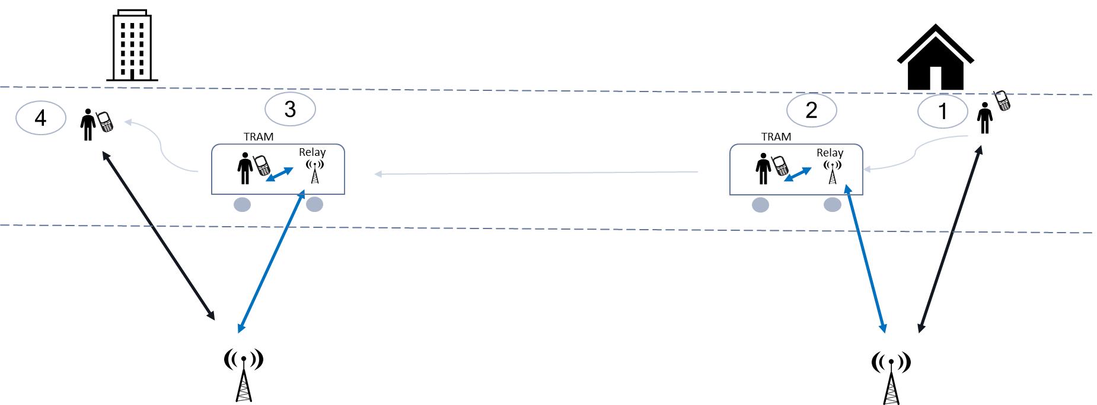

Figure 5.11.1-1

##### 5.11.1.1.4 Post-conditions

While walking to the office building, Alice thanks her secretary for the helpful de-brief and hangs up; she feels very well prepared for the busy working day ahead.

##### 5.11.1.1.5 Existing features partly or fully covering the use case functionality

Current requirements (e.g. related to wireless self-backhaul, see 22.261, sec 6.12) or existing functionalities (e.g. IAB), cover scenarios of autonomous configuration/adaptation of network topologies, but do not assume or fully address physical relay mobility.

##### 5.11.1.1.6 Potential New Requirements needed to support the use case

[PR 5.11.1-1] The 5G system shall be able to support efficient handover when a UE active communication changes from the macro network to a mobile base station relay (e.g. mounted on a vehicle) and vice versa, ensuring end-to-end service continuity during mobility of the UE (e.g. entering or leaving the vehicle) and/or the relay.

#### 5.11.1.2 Use case 2: User outside the vehicle

##### 5.11.1.2.1 Description

When moving to an area where coverage from mobile base station relay(s) is available, the UE can be handed over from the macro network to a suitable mobile base station relay. Conversely, when the UE served by a mobile base station relay is heading out of the area where coverage from mobile base station relay(s) is available, the UE can be handed over from the relay to the macro network. In both cases, ensuring that there is no interruption in the ongoing services at the UE will yield an improved user experience.

##### 5.11.1.2.2 Pre-conditions

Anna lives in a residential area within walking distance of the city center. She gets good 5G service from the macro network around her house thanks to the lack of tall buildings and the fact that the area is not densely populated. Anna works in the city center and likes to go to the office on foot. Often, to save time, she takes conference calls on her way to work.

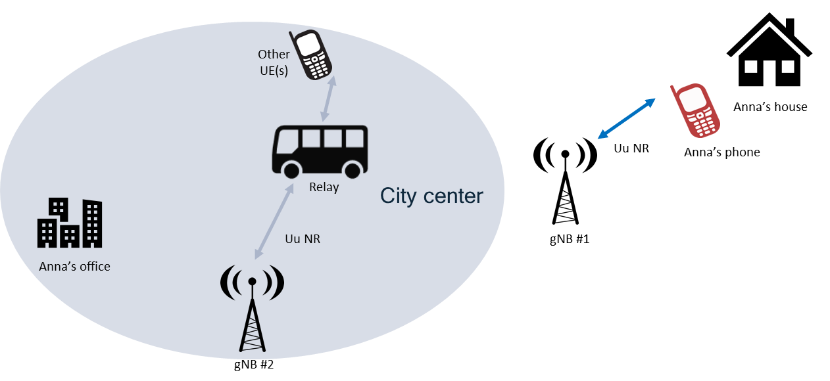

Figure 5.11.1-2

##### 5.11.1.2.3 Service Flows

1. It’s 7:55 am and Anna gets out of her house to walk to work. She has a conference call at 8 am so she starts the conferencing app on her phone and connects her headset.
2. At 8:25 am, Anna arrives in the city center. Anna’s boss asks her to give an update on the project she is working on. Anna starts giving her presentation.
3. Due to the high-rise buildings in the center, the macro coverage gets spotty, and due to the high number of UEs, the data rate allocated to Anna’s phone starts going down. Anna’s boss starts asking her questions on the updates she has presented.
4. Traffic in the center is very packed and there are buses equipped with mobile station relays on the avenue where Anna is walking. The macro network determines that Anna’s phone can get better coverage from a relay than from the macro and hands over Anna’s phone to the relay in the bus closest to Anna. All ongoing services in the phone, including the conference call, are transferred without service interruption.

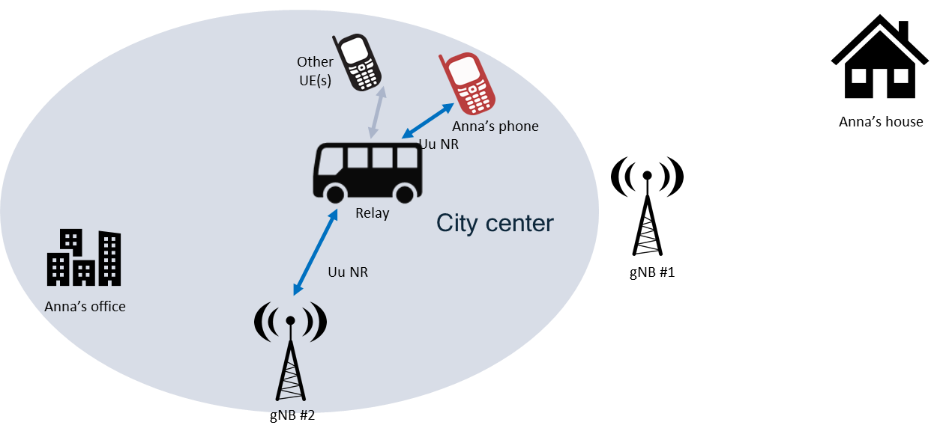

Figure 5.11.1-3

1. Anna’s phone regains good coverage and maximum data rate, enabling Anna to not miss any of her boss’s questions and to provide answers. Anna’s boss congratulates her for the good progress on her project.
2. Anna’s conference call continues and her colleagues give updates on their own project. Anna arrives in front of her office building and enters the building, while the bus in which the relay is installed continue alongside the avenue
3. The network determines that the serving relay and Anna’s phone are moving in diverging directions and hands over Anna’s phone the macro cell serving Anna’s office building. All ongoing services in the phone, including the video call, are transferred without service interruption.

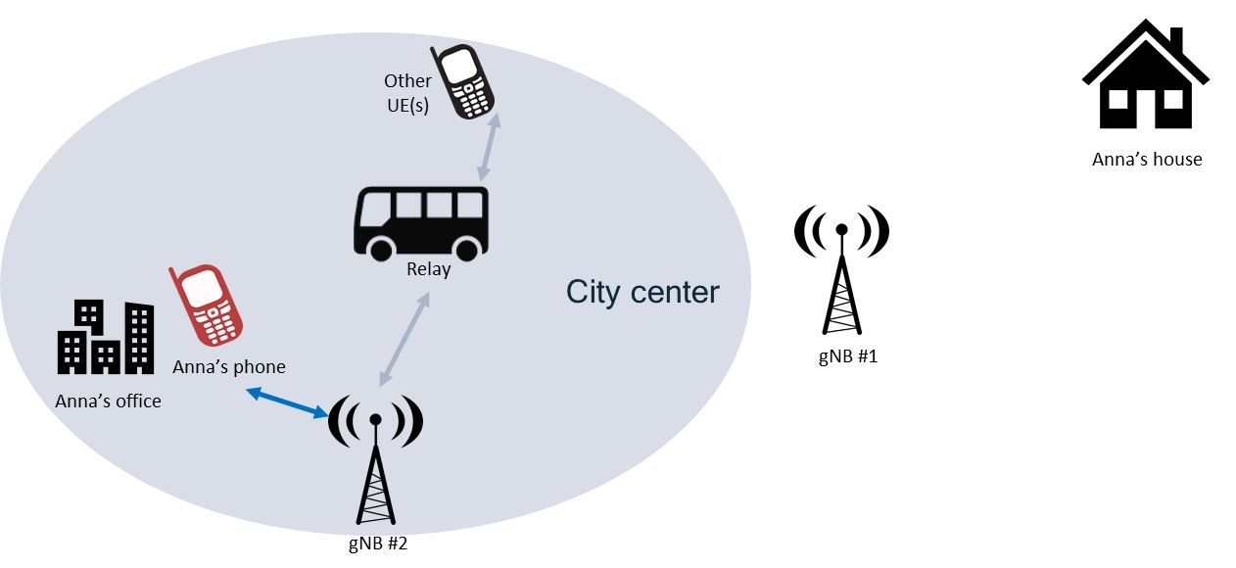

Figure 5.11.1-4

1. Anna finishes her conference call, and goes to her office.

##### 5.11.1.2.4 Post-conditions

Anna’s conference call was transferred seamlessly from the macro network to the mobile base station relay and then back to the macro network.

Anna is very pleased that she was able to participate in the call without service outage, which enabled her to complete her presentation, answer all questions, and listen to her colleagues’ updates.

##### 5.11.1.2.5 Existing features partly or fully covering the use case functionality

Current requirements (e.g. related to wireless self-backhaul, see 22.261, sec 6.12) or existing functionalities (e.g. IAB), cover scenarios of autonomous configuration/adaptation of network topologies, but do not assume or fully address physical relay mobility.

##### 5.11.1.2.6 Potential New Requirements needed to support the use case

[PR 5.11.1-2] The 5G system shall be able to support efficient handover when a UE active communication changes from the macro network to a mobile base station relay (e.g. mounted on a vehicle) and vice versa, ensuring end-to-end service continuity during mobility of the UE (e.g. moving outside the vehicle) and/or the relay.

### 5.11.2 Mobility of relay between macro nodes

#### 5.11.2.1 Use case 1: User inside the vehicle

##### 5.11.2.1.1 Description

While the UE is served by a mobile base station relay, as the vehicle is moving, it is possible for the relay to be handed over to a different macro node. Ensuring that there is no interruption to the ongoing services at the UE will yield an improved user experience.

##### 5.11.2.1.2 Pre-conditions

Jim is going on a business trip that was scheduled on very short notice. To prepare for the trip, he has set up a conference call with this team that will take place during his commute to the airport using his favorite ride-sharing service, whose vehicles happen to be equipped with mobile station relays.

Jim settles into his ride and opens his laptop which has with a 5G modem. The modem in the laptop registers with the mobile base station relay mounted on the vehicle. Jim starts his conference call and shares the slides he has prepared.

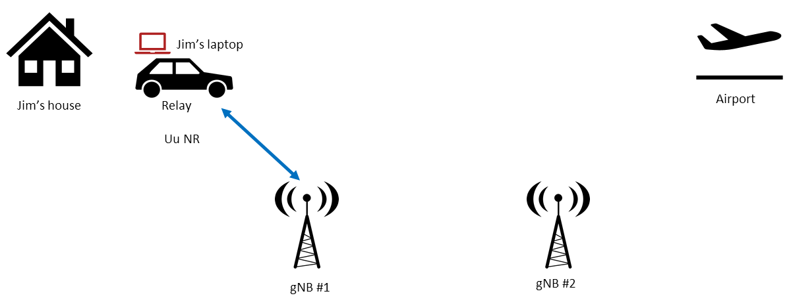

Figure 5.11.2-1

##### 5.11.2.1.3 Service Flows

1. Jim’s ride goes onto the highway and heads for the airport. As the vehicle moves away from the city, coverage from the serving macro node to the relay becomes weaker.
2. The macro network determines that the relay can be better served by another macro node, and hands over the relay to that macro node. All ongoing services on Jim’s laptop, including the conference call with slide sharing, are transferred without service interruption.
3. Jim arrives to the airport, thanks his team and ends the conference call.

##### 5.11.2.1.4 Post-conditions

Jim’s conference call and slide sharing were transferred seamlessly during handover of the relay serving Jim’s laptop from one macro node to another. Jim is very pleased that he was able to make the most of the ride time and go through the entire slide deck without any interruption in connectivity.

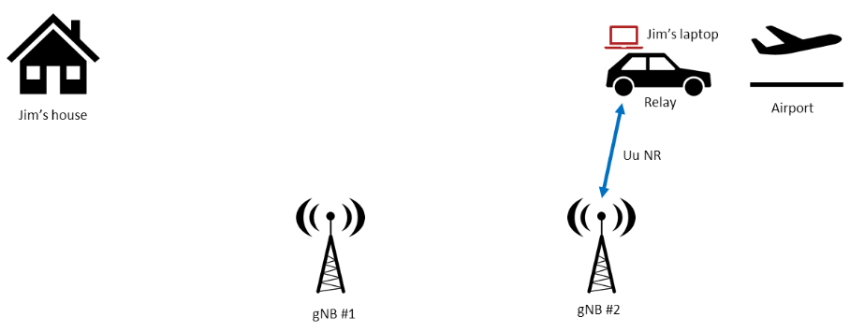

Figure 5.11.2-2

Note: the use case does not assume a particular vehicle’s speed, and may apply also to users and relays inside high-speed trains (up to 500kmph).

##### 5.11.2.1.5 Existing features partly or fully covering the use case functionality

Current requirements (e.g. related to wireless self-backhaul, see 22.261, sec 6.12) or existing functionalities (e.g. IAB), cover scenarios of autonomous configuration/adaptation of network topologies, but do not assume or fully address physical relay mobility.

##### 5.11.2.1.6 Potential New Requirements needed to support the use case

[PR 5.11.2-1] The 5G system shall be able to support efficient handover of a UE active communication when a mobile base station relay (e.g. serving a UE inside a vehicle) changes between macro network nodes, ensuring end-to-end service continuity during mobility of the relay.

#### 5.11.2.2 Use case 2: User outside the vehicle

##### 5.11.2.2.1 Description

In certain scenarios, a mobile base station relay mounted on a vehicle may serve UEs outside, and while the vehicle is moving the relay connection to the macro network can change, i.e. can be handed over to a different macro donor node. In such cases, the system should ensure seamless mobility and service continuity.

The example scenario described here refers to an outdoor sport event (bike or pedestrian race), with motorbikes’ camera transmitting real-time video via relays mounted on alongside vehicles, e.g. provided by the event organizer or TV broadcaster. During the race, the vehicle relay changes macro cell coverage, i.e. relay connection is handed over between two macro donor nodes.

##### 5.11.2.2.2 Pre-conditions

Before the race starts, cameras on motorbikes get configured and connected to a surrounding vehicle relay, providing 5G wireless backhauling connectivity toward a certain PLMN network.

Real-time video transmission starts, and the vehicle relay is connected to macro cell (donor node) #1.

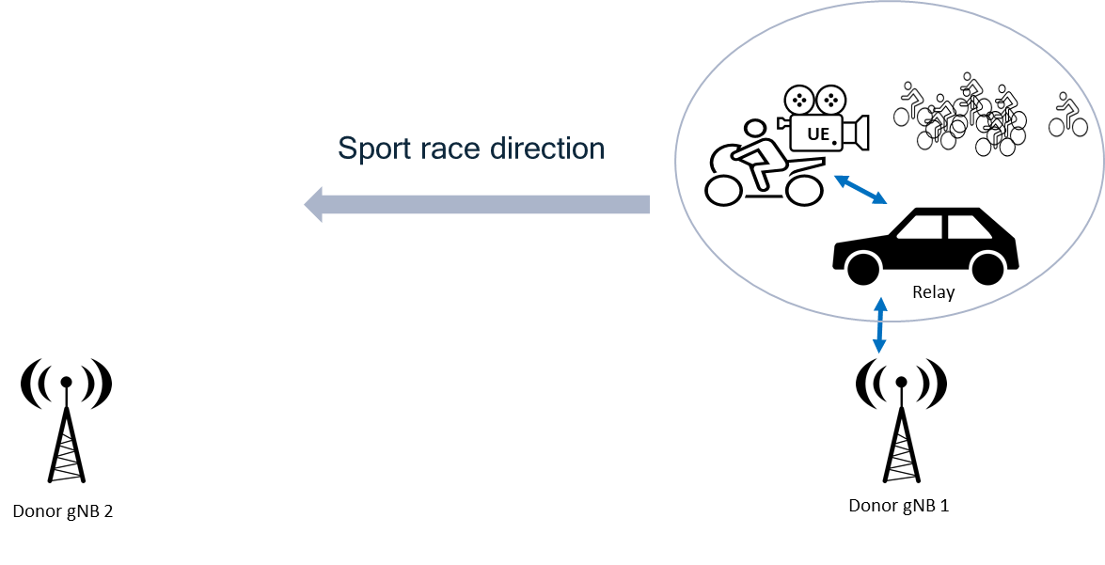

Figure 5.11.2-3

##### 5.11.2.2.3 Service Flows

1. The sport race starts; motorbikes with cameras and cars equipped with relays follow, on the side, the race group/platoon.
2. While moving along the race itinerary, the relay coverage and connection quality from macro cell#1 gets weaker, and macro cell#2 becomes a stronger/better cell to connect to.
3. Based on NW decision, at a certain point the relay backhaul connection is handed over from cell#1 to cell#2, while UEs (cameras) remain connected to the same relay.

##### 5.11.2.2.4 Post-conditions

The vehicle relay is connected to macro cell#2, and no service disruption occurred to the ongoing video transmission.

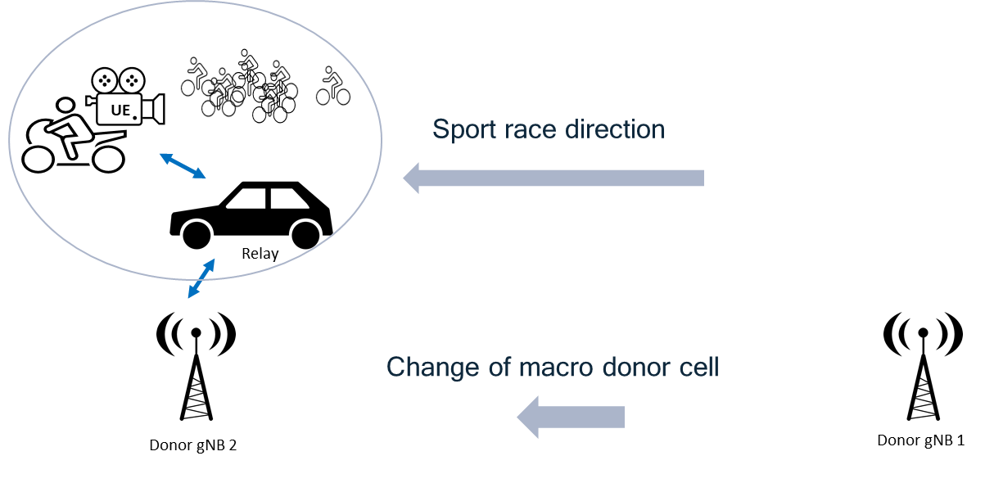

Figure 5.11.2-4

##### 5.11.2.2.5 Existing features partly or fully covering the use case functionality

Current requirements (e.g. related to wireless self-backhaul, see 22.261, sec 6.12) or existing functionalities (e.g. IAB), cover scenarios of autonomous configuration/adaptation of network topologies, but do not assume or fully address physical relay mobility.

##### 5.11.2.2.6 Potential New Requirements needed to support the use case

[PR 5.11.2-2] The 5G system shall be able to support efficient handover of a UE active communication when a mobile base station relay (e.g. serving a UE outside a vehicle) changes between macro network nodes, ensuring end-to-end service continuity during mobility of the relay.

### 5.11.3 Mobility between relays

#### 5.11.3.1 Use case 1: User inside the vehicle

##### 5.11.3.1.1 Description

Some big size vehicles, e.g. trains or trams, can require multiple 5G base station relays to provide good coverage to users/UEs located in different parts of the vehicle. In such cases, if active users/UEs move around the vehicle their connection can switch between different relays.

In the example described hereafter, Tom is travelling on a high-speed train that provides 5G on board coverage (from his HLMN) by using relays installed 2-3 wagons apart, connected via wireless backhaul to the wide-area 5G macro RAN.

##### 5.11.3.1.2 Pre-conditions

Tom is seating on the train and his smartphone is camped on a local (HPLMN) 5G relay inside/nearby his wagon. It’s almost lunch time, and he’s thinking to go and eat something at the small restaurant/bar available on the train, located few wagons away. Meanwhile, Tom receives a video-chat call from his wife.

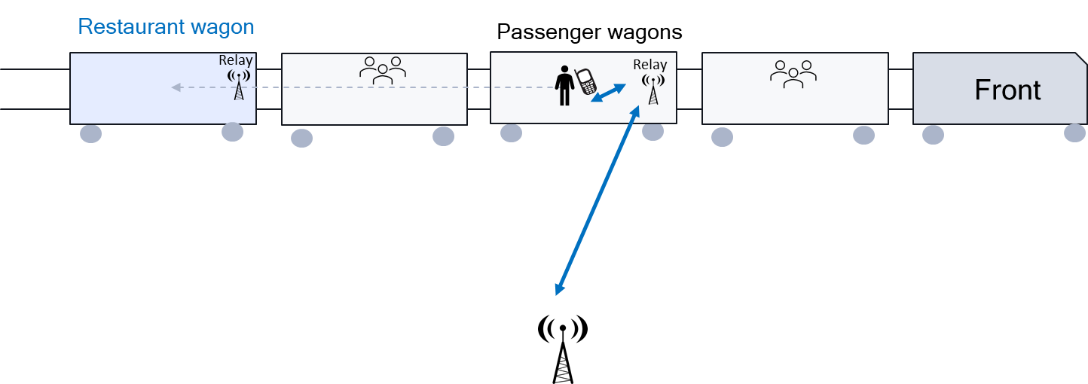

Figure 5.11.3-1

##### 5.11.3.1.3 Service Flows

1. Tom has started a call, using 5G connectivity from the close-by 5G relay (e.g. inside his wagon)
2. During the call, Tom moves to the restaurant wagon, which is covered by another 5G relay.
3. While moving between wagons, connectivity quality/strength of the first relay decreases, while coverage from the relay in the restaurant wagon becomes available and stronger.
4. When Tom gets closer to restaurant wagon, the call is handed over from the first relay to the second relay, using the same donor macro node.

##### 5.11.3.1.4 Post-conditions

Tom arrives at the restaurant without perceiving any disruption to the ongoing call and can continue enjoying his phone conversation while seating at the bar.

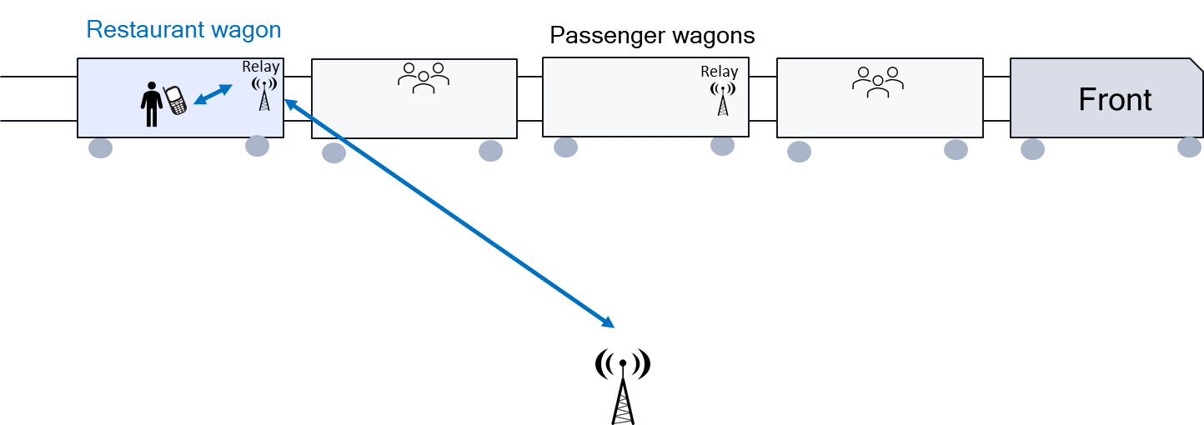

Figure 5.11.3-2

Note: the use case does not assume a specific vehicle’s speed, and may apply also to high-speed trains (up to 500kmph).

##### 5.11.3.1.5 Existing features partly or fully covering the use case functionality

Current requirements (e.g. related to wireless self-backhaul, see 22.261, sec 6.12) or existing functionalities (e.g. IAB), cover scenarios of autonomous configuration/adaptation of network topologies, but do not assume or fully address physical relay mobility.

##### 5.11.3.1.6 Potential New Requirements needed to support the use case

[PR 5.11.3-1] The 5G system shall be able to support efficient handover when a UE active communication changes between mobile base stations relays (e.g. mounted on a vehicle), ensuring end-to-end service continuity during mobility of the UE (e.g. moving inside the vehicle).

#### 5.11.3.2 Use case 2: User outside the vehicle

##### 5.11.3.2.1 Description

While a user is located in an area where coverage from mobile base station relay(s) is available, the user’s UE can be handed between mobile base station relays due to mobility of the relays. Ensuring that that there is no interruption in the ongoing services at the UE during such handover will yield an improved user experience.

##### 5.11.3.2.2 Pre-conditions

Tom has made plans to have lunch with friends at a sushi restaurant downtown. The food there is very good, plus the restaurant is conveniently located across from the downtown bus transit hub/station, which enables Tom to reach the restaurant easily by public transportation. All buses in Tom’s city are equipped with mobile base station relays.

Tom arrives early at the restaurant and sits down at a table. His phone registers with the mobile base station relay mounted on a bus across the street awaiting departure. Tom starts streaming his favorite TV show on his phone while waiting for his friends.

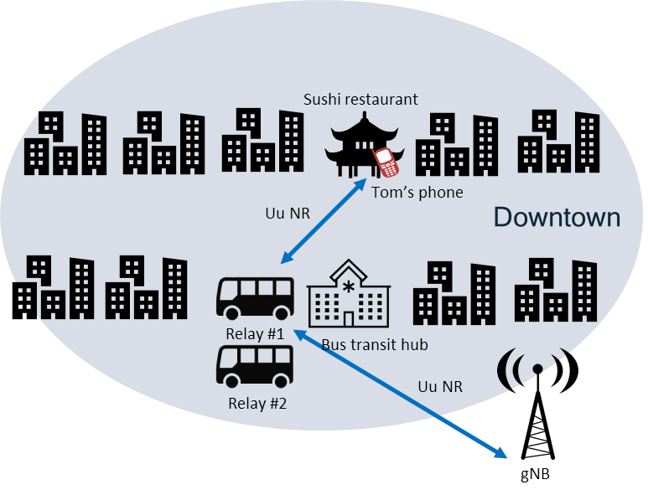

Figure 5.11.3-3

##### 5.11.3.2.3 Service Flows

1. The driver of the bus equipped with the mobile base station relay serving Tom’s phone gets in the bus and prepare to depart. The driver turns on the engine, closes the doors, and starts driving the bus toward the exit of the bus transit hub, then makes a left into the avenue.
2. The network determines that the serving relay is moving away from Tom’s phone and hands over Tom’s phone to a relay located in another bus awaiting departure at the bus transit hub. All ongoing services in the phone, including the streaming of the TV show, are transferred without service interruption.
3. Tom’s friends arrive at the restaurant, and they order lunch.

##### 5.11.3.2.4 Post-conditions

Tom’s streaming video was transferred seamlessly from the mobile base station relay mounted on the first bus, to a mobile base station relay mounted the second bus. Tom is very pleased that he was able to watch his TV show without interruption while he was waiting for his friends.

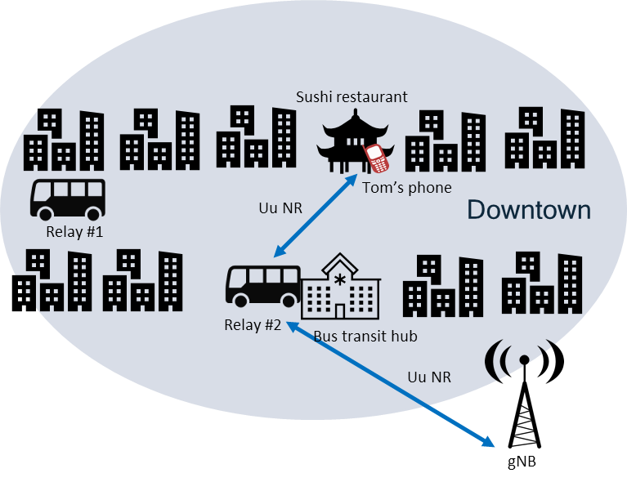

Figure 5.11.3-4

##### 5.11.3.2.5 Existing features partly or fully covering the use case functionality

Current requirements (e.g. related to wireless self-backhaul, see 22.261, sec 6.12) or existing functionalities (e.g. IAB), cover scenarios of autonomous configuration/adaptation of network topologies, but do not assume or fully address physical relay mobility.

##### 5.11.3.2.6 Potential New Requirements needed to support the use case

[PR 5.11.3-2] The 5G system shall be able to support efficient handover when a UE active communication changes between mobile base stations relays (e.g. mounted on a vehicle), ensuring end-to-end service continuity during mobility of the UE (e.g. moving outside the vehicle) and/or the relays.

### 5.11.4 Group UEs’ service continuity

#### 5.11.4.1 Description

After a bus is installed of mobile BS relay, the passengers in the bus can be served by the relay. When the bus is moving, it is possible for the relay to be handed over to a different macro node. Thus, no interruption to the ongoing services at the UEs in the bus will yield an improved user experience.

#### 5.11.4.2 Pre-conditions

The city bus company has assigned contract with operator AA to install mobile BS relay on the city buses. All the passengers in the buses can be served by the relay.

Passenger Anna, Jim are in the city bus RED. Anna opens her tablet and registers with the mobile base station relay mounted on the bus. She begins to play online game through her tablet. Jim opens his smartphone to register with the relay mounted on the bus then begins to view online video.

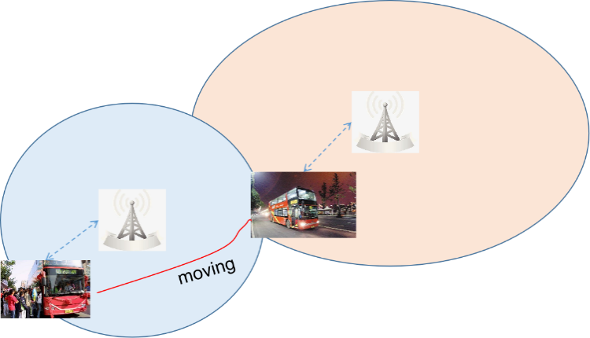

Figure 5.11.4-1: Anna and Jim in the city bus RED

#### 5.11.4.3 Service Flows

1. RED bus moves along its route and the mobile base station relay mounted on the bus connecting with the serving macro node provides communication service for its passengers.
2. When it is moving, the radio signal which the relay received becomes weak.
3. The 5G system identifies that the relay can be better served by another macro node, and hands over the relay to that macro node.
4. All ongoing traffic of the passengers in the bus e.g. Jim’s video, Anna’s game etc. are transferred without service interruption.

#### 5.11.4.4 Post-conditions

Anna’s online gaming can go well during she is in the bus.

Jim’s video can be viewed well either during he is in the bus.

Note: the use case does not assume a particular vehicle’s or speed, and may apply also to users and relays inside high-speed trains (up to 500kmph). And the number of active passengers in a vehicle can be large (e.g. up to 100 in a train).

#### 5.11.4.5 Existing features partly or fully covering the use case functionality

Current requirements (e.g. related to wireless self-backhaul, see 22.261, sec 6.12) or existing functionalities (e.g. IAB), cover scenarios of autonomous configuration/adaptation of network topologies, but do not assume or fully address physical relay mobility.

#### 5.11.4.6 Potential New Requirements needed to support the use case

[PR 5.11.4-1] The 5G system shall be able to support efficient handover of a group of UEs’ active communications when a mobile base station relay serving a group of in vehicle UEs moves between donor gNBs, ensuring end-to-end service continuity during mobility of the relay.

## 5.12 Optimizing UE mobility from planned or predicted mobility information

### 5.12.1 Description

Urban buses of a city are equipped with a mobile base station relay i.e. Vehicle-mounted Relays (VMRs).

The city provides also autonomous cars rental for moving in the centre or in the suburb of the city. Autonomous cars of the city may follow the same corridors as the city buses.

Each autonomous car is equipped with a built-in UE and a roof antenna.

Bob is going to work. Bob hires one autonomous car and configures the path to go to his work office in the car.

Along the path to the work office, the autonomous car’s UE can connect to different fixed base stations or mobile base station relays providing a better signal quality for a short period, thereby triggering a large number of handovers. This can be inefficient, since it is preferred that his car’s UE selects a fixed base station or a mobile base station relay that provides good connectivity for a longer duration.

To minimize the number of handovers and to provide a service continuity, the 5G system can predict the usual itinerary of a UE as well as that of neighbouring VMRs to select the best fixed base station or mobile base station relay for the UE alongside a given usual travel itinerary.

In the provided use-case, the car’s UE connects to the VMR of Bus 2 that follow the car’s UE itinerary for an important portion of the itinerary. Should the bus stop and the car continue, then the received Bus 2 VMR signal level will drop and a new handover decision will be necessary. In this case, both signal level and the mobility information will be used as before to select another fixed base station or a mobile base station relay.

### 5.12.2 Pre-conditions

The following pre-conditions and assumptions apply to this use case:

1. MNO 1 operates car’s UE, VMR 1 (Bus 1), VMR 2 (Bus 2), BS 1 (Base Station).
2. Bob is going to work and hire an autonomous car embedding a car’s UE.
3. Bob configures the path in the autonomous car with the itinerary to work.
4. Car’s UE is currently connected to a Base station (BS 1).

### 5.12.3 Service Flows

1. The car (car’s UE) is following two buses, Bus 1 (VMR 1) and Bus 2 (VMR 2).

2. The network signal conditions become better from the mobile base station relays (VMRs) than from the fixed base station (BS 1).

3. Bus 2 will be turning left at the next corner while Bus 1 will continue to follow the same direction as Bob’s car.

4. The 5G system finds that Car’s UE itinerary has a high probability of following the direction of Bus 1 (VMR 1) and a low probability of following the direction of Bus 2 (VMR 2).

5. Car’s UE connects to VMR 1.



Figure 5.12-1: Illustration of service flow / use case

### 5.12.4 Post-conditions

Bob continues to attend to his conference call with his UE while being in his car.

### 5.12.5 Existing features partly or fully covering the use case functionality

3GPP TS 22.261 [2] clause 6.2.2: The 5G network shall allow operators to optimize network behaviour (e.g. mobility management support) based on the mobility patterns (e.g. stationary, nomadic, spatially restricted mobility, full mobility) of a UE or group of UEs.

3GPP TS 22.261 [2] clause 6.2.2: The 5G system shall enable operators to specify and modify the types of mobility support provided for a UE or group of UEs.

3GPP TS 22.261 [2] clause 6.2.2: The 5G system shall support inter- and/or intra- access technology mobility procedures within 5GS with minimum impact to the user experience (e.g. QoS, QoE).

### 5.12.6 Potential New Requirement needed to support the use case

[PR.5.12.6-001] The 5G system shall provide means for a UE to select a suitable mobile base station relay (e.g., a mobile base station relay that has a similar trajectory as the UE).

## 5.13 Use of mobile relay as secondary node

### 5.13.1 Description

A user served by a macro cell can enter an area where vehicles equipped with mobile base station relays are parked or running a low speed. In this case, it can be beneficial to use a suitable candidate relay to provide a simultaneous access link for the UE, e.g. enabling to increase user data rates and/or improve coverage during the time the relay is in the vicinity of the user. Keeping the simultaneous link to the macro cell can ensure that there is no interruption of service, e.g. in case the user and/or the relay move away from each other too quickly (e.g. when a parked/stationary vehicle with a mobile base station relay drives off).

### 5.13.2 Pre-conditions

Tom lives in a residential area within walking distance of the city center. He gets good 5G service from the macro network around his house. Tom works in the city center and likes to go to the office on foot. Often, he takes conference calls from his smartphone on his way to work.

It is assumed that

* Primary RAN connectivity should be provided via a macro RAN link (i.e. non relayed link, as opposed to a link via a mobile BS relay). This may increase connection quality and availability, e.g. in case macro RAN connectivity uses lower frequency bands than BS relays, or in areas where vehicles (with mobile BS relays) are moving quickly and/or may provide only temporary connectivity.
* The RAN cell (re)selection settings are such that Tom’s UE tries to camp/reselect to a macro RAN node (preferred versus a mobile base station relay), if macro RF quality is suitable. This will increase the possibility to set up a 5G connection via the macro RAN as primary link.
* The simultaneous UE access links to the RAN (via the macro link and mobile BS relay) could be connected to the same or different RAN node(s).

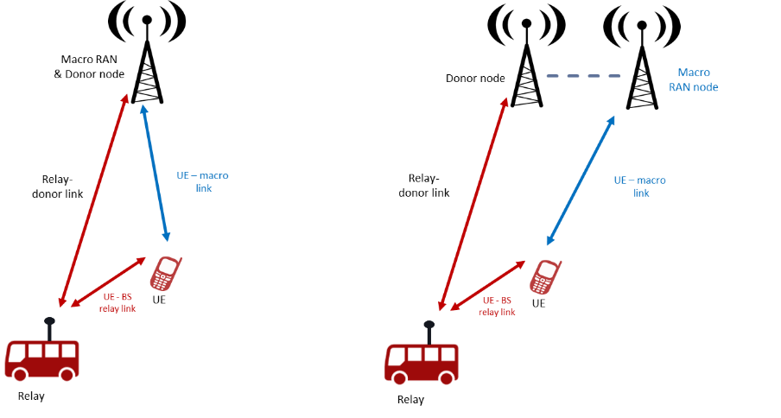

Figure 5.13 Simultaneous UE connection to RAN (via macro link and mobile relay link)

In the service flow below, the figures show the case of same (or co-located) RAN nodes, for simplicity.

### 5.13.3 Service Flows

1. It’s 7:55 am and Tom gets out of his house to walk to work. His phone camps on a macro cell on frequency f1. Tom has a conference call at 8 am so he starts the conferencing app on his phone and connects his headset.

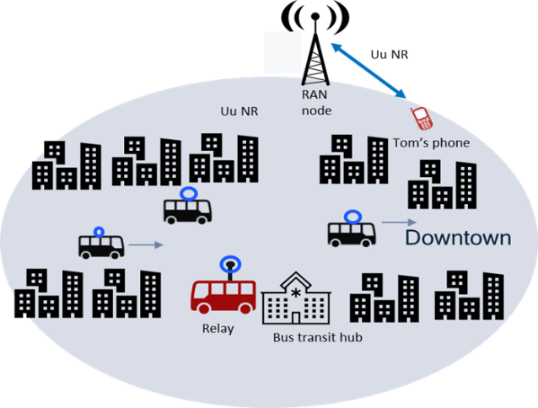

Figure 5.13-1

1. At 8:25 am, Tom arrives in the city center. Tom’s boss asks him to urgently email him documents related to the project Tom is working on, in preparation for a briefing with executives.
2. Due to the high-rise buildings in the center, the macro coverage gets spotty, and due to the high number of UEs, the data rate allocated to Tom’s phone starts going down. Tom starts emailing the documents to his boss but the upload speed is very slow.
3. Tom arrives next to the bus transit hub, where a bus equipped with a mobile base station relay operating on frequency f2 is parked. The macro network determines that Tom’s phone can get supplemental throughput from the relay in the bus and adds the relay as secondary node.
4. Tom’s phone regains good data rate performance, and all his documents are uploaded successfully.

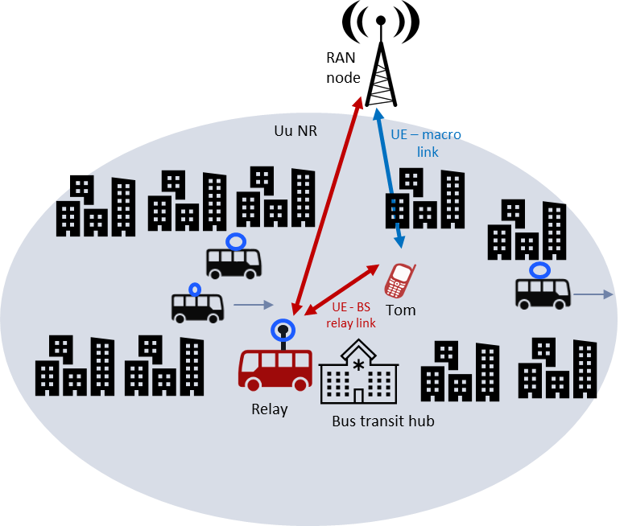

Figure 5.13-2

1. The driver of the bus turns on the ignition and drives out of the bus transit hub on his scheduled bus route.
2. The network determines that the relay in the bus is moving away from Tom’s phone, and removes the relay as secondary node, while the link to the macro cell is kept as primary node.

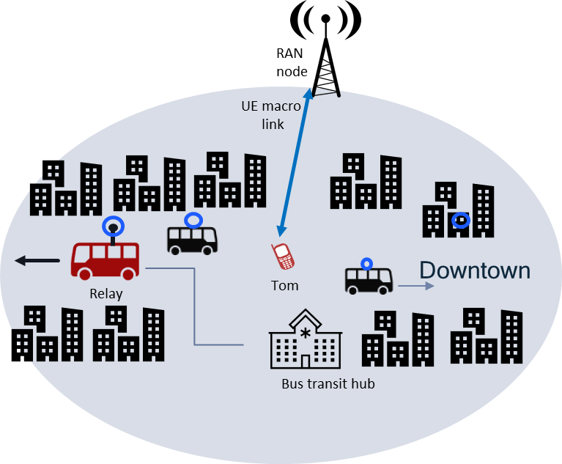

Figure 5.13-3

1. Tom ends his conference call.

### 5.13.4 Post-conditions

Tom is very pleased that he was able to upload all his documents in time, while participating in the conference call without service interruption throughout his commute to work.

Upon call release, based on RAN settings (as described in the pre-conditions), Tom’s phone camps on the macro cell, rather than surrounding mobile base station relays.

### 5.13.5 Existing features partly or fully covering the use case functionality

Current requirements (e.g. related to wireless self-backhaul, see 22.261, sec 6.12) or existing functionalities (e.g. IAB plus CA/DC), cover some scenarios of simultaneous connectivity between relay and macro nodes, and do not assume or fully address physical relay mobility.

### 5.13.6 Potential New Requirements needed to support the use case

[PR.5.13.6-001] The 5G system shall be able to efficiently control UE idle mode mobility when mobile base station relays are used, e.g. to facilitate UEs connecting to the macro RAN (as opposed to a vehicle relay).

[PR.5.13.6-002] The 5G system shall be able to support simultaneous UE connectivity to RAN, using a direct UE access link to the macro RAN together with an access link via a mobile base station relay (e.g. mounted on a vehicle).

NOTE 1: the above requirement covers the scenarios were the UE access links (to the macro RAN and via the mobile BS relay) could be connected to the same or different RAN node(s).

NOTE 2: the above requirement includes supporting efficient addition and removal of a simultaneous access link, e.g. adding and removing a UE access link via a mobile base station relay while the UE is connected to the macro RAN.

## 5.14 Optimized relay for in-vehicle devices

### 5.14.1 Description

There are scenarios where it is possible to improve performance of 5G UEs inside a vehicle, camped or connected via the vehicle relay to the 5G network, in particular when the UE is known to be located inside the vehicle. Some examples are:

* Medical devices in an ambulance (pre-installed, or portable)
* IOT/tracking devices used for goods delivery/transport, vehicle/asset monitoring, etc
* Cameras or other multi-media devices mounted on vehicles following an outdoor sport event
* Users’ UEs that “check-in” their presence in the vehicle

In some cases, e.g. for devices in ambulances, or vehicles used for multimedia applications, where UEs could be pre-installed or have fixed location, the exact position inside the vehicle, relative to the BS relay, can also be identifiable.

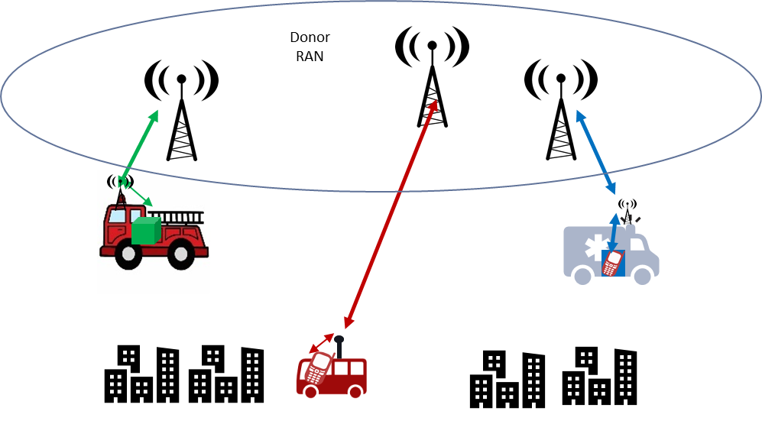

Figure 5.14-1: Example scenarios

### 5.14.2 Pre-conditions

Vehicle is equipped with a mobile BS station relay.

UEs can be pre-installed in the vehicle (permanently or semi-static), or can be portable and move in and out of the vehicle.

The UEs inside the vehicle, authorized to access the 5GS via the in-vehicle 5G mobile BS relay, are set to camp and connect (only or preferably) via the vehicle relay.

### 5.14.3 Service Flows

Pre-installed UEs are configured to access via the vehicle relay.

Portable IOT devices/wearables and/or UEs can “check-in” their presence/location in the vehicle, manually (e.g. user onboard, using UE’s scan or app-based check-in), or based on some form of device-relay pairing (e.g. using 3GPP direct discovery/ranging, or other mechanisms).

The RAN/relay can optimize mobility configuration (e.g. minimizing/disabling reselections and handovers) and/or UE battery life (e.g. minimizing/avoiding UE measurements, etc.).

Radio signal and RF power settings could also be tuned to provide best link and connectivity quality for each device, if relative position between UE and relay is known.

### 5.14.4 Post-conditions

UEs inside the vehicle remain camped and connected all the time via the vehicle relay, with no unnecessary reselection/handover ping-pongs (to/from macro), experiencing very good performance and/or saving battery life.

### 5.14.5 Existing features partly or fully covering the use case functionality

Current stage-1 requirements (e.g. on wireless self-backhaul, in TS 22.261), as well as existing stage-2/3 functionalities and architecture options (e.g. IAB) do not assume or address full relay mobility (e.g. BS relays on board of moving vehicles), thus may not cover the identified new potential requirements, which are intended to be specific to mobile BS relays.

### 5.14.6 Potential New Requirements needed to support the use case

[PR.5.14.6-001] The 5G system shall be able to support mechanisms to optimize mobility (e.g. re-selection, handover) and energy efficiency for a UE camped or connected via a vehicle mobile BS relay (e.g. for UEs located inside a vehicle, equipped with a BS relay).

5.15 Transient Coverage Extension

5.15.1 Description

Mobile wireless communications apply to outdoor scenarios. In remote areas, satellite access or self-backhaul provide a clear solution for extending the range of / complementing a mobile network.

For indoor scenarios, beyond the point where outdoor access penetrates, currently 3GPP offers two possibilities.

One is for the indoor premises to deploy non-3GPP access. Through this, a terminal can access a mobile network to get telecommunication services (or access Internet services directly.) This possibility is enabled since Release 7 (IWLAN interworking) by this and later 3GPP standards.

A second possibility is to offer coverage extension, indoors – either through wireless repeaters or a fixed infrastructure in the indoors premises. This is discussed in TR 22.867, Annex A.

A new possibility is presented in this use case – to make use of a number of vehicles to create a transient wireless topology of multiple vehicular relays capable of supporting indoor coverage where it would otherwise not be feasible.

A similar scenario was considered in FS_REFEC (TR 22.866, clause 6.7) as a Traffic Scenario for Public Safety. A number of firefighters penetrate a building without indoor macro cellular coverage and deploy a set of portable (UE) relays in strategic places, e.g. the top and bottom of stairwells, as they access portions of the build with poor or no coverage otherwise.

In this use case, there is a large underground parking structure with no coverage nor is there an incentive or possibility (e.g. due to safety issues) to create fixed coverage extension. Other examples of this could be waste disposal sites, inactive mines, abandoned properties, search and rescue operations in challenging terrain in remote areas (e.g. caves), through underground intrastructure (e.g. sewers, water supply, transit tunnels) or building complexes where investment in coverage extension does not occur.

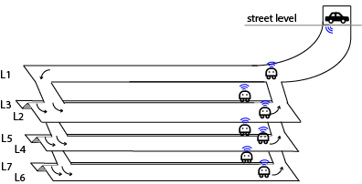

Figure 5.15.1-1: Underground Parking Garage with Transient Network Extension

Unlike the case studied in REFEC, this scenario involves vehicular mobile relays providing 5G coverage extension from outdoor to indoor.

5.15.2 Pre-conditions

The following are assumed to be available for this use case:

- 5G macro cellular coverage to the *exterior* of the facility into which transient coverage is required, e.g. to connect users, sensors or other IoT devices in the facility. In Figure 5.x.1-1, this is the vehicle parked across the entrance of the garage;

- a set of vehicles equipped with relays, configured to work together to provide a network topology. These vehicles could proceed autonomously, controlled remotely or be driven by personnel. In Figure 5.x.1-1, these are the mobile vehicle relay nodes.

- a topography consisting of regions that are accessible to vehicles, portions of which need coverage, even if temporarily or ad hoc coverage. In Figure 5.x.1-1, this is the concrete (and steel) underground parking complex shown only schematically.

5.15.3 Service Flows

The mobile relays proceed into the vicinity of the facility that lacks coverage, in this case the garage. Where necessary, vehicles remain in positions that advance the coverage into the topology. Other vehicles continue, to bring coverage specifically to portions of the facility that need it. The mobile relays topology may change depending on dynamic coverage demand, e.g the vehicle relays can move or reconfigure to provide access to different areas or moving users, when and where indoor coverage is required.

5.15.4 Post-conditions

Sensors and other IoT devices in the facility (for example air quality meters in the parking garage), as well as users who need only periodic connectivity (e.g. to upload and download data opportunistically), will receive connectivity from the transient coverage extension. This will enable data collection from a range of otherwise isolated devices and other communication on a periodic basis, or as needed (e.g. during a disaster response).

The service that is provided to the end systems is 3GPP service (not ProSe UE to network.)

5.15.5 Existing features partly or fully covering the use case functionality

NR Rel-16 introduces a relaying architecture enabling routing across a backhaul network of relay nodes which uses NR-Uu interface to interconet relay nodes, enabling data transfer from network access node to the end-user, and back: IAB. In Rel-17, IAB is currently being enhanced, although relay (IAB-node) mobility is not being taken into account.

5.15.6 Potential New Requirements needed to support the use case

[PR.5.15.6-001] The 5G System shall be able to support dynamic deployment and configuration of one or more mobile base station relays (e.g. mounted on vehicles) for providing ad-hoc indoor coverage extension in specific locations.

## 5.16 Non-terrestrial coverage for Mobile Vehicular Relays

### 5.16.1 Description

Wireless self-backhauling relays considered in 3GPP generally assume a terrestrial (fixed) base station providing wireless access to the relay nodes. In this use case, access to a very remote mobile relay is supported by means of a non-terrestrial platform.

This introduces two complicating factors:

- The latency for signalling across the network (between the relay nodes and the node providing access to the relay) will be much higher than in terrestrial networks.

- The non-terrestrial platform providing relay connectivity itself may be mobile (in all cases except a GEO NTN access node.)

This could be needed – for example, to support vehicular relays that are out of coverage of terrestrial networks, e.g. in remote areas. Even where terrestrial coverage exists, the vehicular relay may use satellite coverage.

Where satellite access is described in this use case, both the transparent and regenerative NG-RAN architectures could apply. [y]

### 5.16.2 Pre-conditions

The following are assumed to be available for this use case:

- 5G access is provided in a certain area by a non-terrestrial platform (e.g. a LEO, MEO satellite);

- a set of vehicles equipped with 5G mobile BS relays, configured to obtain access from a non-terrestrial platform;

- vehicle relays provide 5G access to UEs inside the vehicle (e.g. those UEs could be normal smartphones, without satellite capabilities.)

### 5.16.3 Service Flows

Two vehicles drive across a remote landscape, 100s of km from any settlement. There is no terrestrial coverage. Some vehicles are equipped to support satellite access and provide passengers of the vehicle with coverage by way of mobile vehicular relay.

In Figure 1, the two vehicles are roughly 1 km apart, driving in the same direction. The satellite platform is also in motion (see the displacement during T1 to T2 – which is not drawn to scale.) Satellite access is available for both vehicles. Even as the satellite moves, the vehicles continue to be in coverage and serve their passengers with relayed coverage.

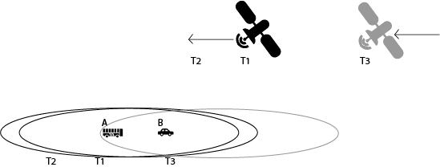

Figure 5.16-1: Vehicle Relays supported by a non-stationary satellite platform

At T3, the black satellite will no longer be able to provide coverage to the vehicles. A separate satellite platform (shown in gray) that is part of the same satellite network *follows*. Even as the first platform cannot offer coverage, the second takes its place. There is thus *continuity* of service by means of a *sequence of transitions* to make use of different satellite platforms offering access to the vehicular mobile relays.

This use case does not differentiate (at the service level) between the situation where the satellites are transparent (in which case the donor RAN is terrestrial), or whether the satellite is regenerative (in which case the donor RAN is the satellite platform itself.)

### 5.16.4 Post-conditions

The vehicles and their passengers are able to access telecommunication services using the satellite relay platform to connect to the remote 5G network.

### 5.16.5 Existing features partly or fully covering the use case functionality

NR Rel-16 introduces a relaying architecture enabling routing across a backhaul network of relay nodes which uses NR-Uu interface to interconet relay nodes, enabling data transfer from network access node to the end-user, and back: IAB. In Rel-17, IAB is currently being enhanced, although relay (IAB-node) mobility is not being taken into account.

### 5.16.6 Potential New Requirements needed to support the use case

[PR5.16.6-1] The 5G System shall be able to support mobile vehicle relays using NR satellite access to connect to a remote donor RAN node via a satellite link.

[PR5.x.6-2] The 5G System shall be able to support a mobile vehicle relay using NR satellite access with service continuity in the scenario where there is a transition from one serving satellite to another serving satellite.

## 5.17 Vehicle Relay sharing

### 5.17.1 Description

A nationwide company, 5G-travels, provides long-distance bus transport service and has recently installed 5G mobile BS relays on their bus fleet, for enhanced 5G connectivity to their passengers. Two national cellular MNOs, PLMN-A and PLMN-B, already using RAN sharing in several areas of the country, make commercial arrangements with the bus company and among themselves, for sharing the use of the bus relays, such that their customers can have access to their respective HPLMN, without roaming.

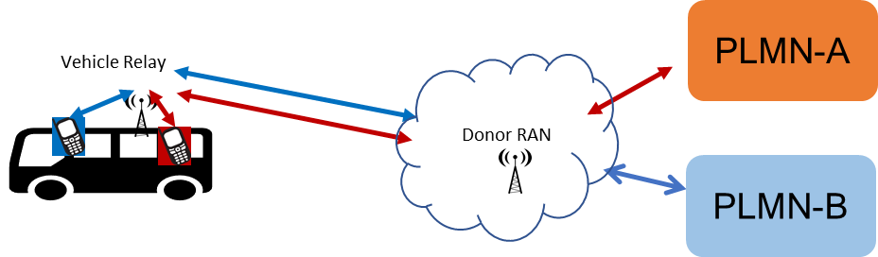

Figure 5.17-1: Multi-PLMN sharing of donor RAN and vehicle relays

### 5.17.2 Pre-conditions

The following aspects and options are assumed in this use case:

- Each PLMN operator has his own 5G core network; both core networks are connected to a certain number of shared donor RAN nodes, deployed along the bus routes, which provide wireless connectivity to the vehicle relays on the buses.

- Spectrum and RAN resources used for UEs and wireless relays access could be managed by either PLMN A or B, or by a hosting operator different from operator A or B

- The vehicle relays will broadcast both PLMN-IDs of the sharing operators, appearing to their users/UEs like their home PLMN network.

- Based on user subscription/UE identity, the shared RAN can route traffic of PLMN-A and PLMN-B customers to/from their corresponding PLMN core network.

- It is assumed that other passengers, without subscription or roaming agreement with either PLMN-A nor B, will not get access via the bus relays. If roaming agreement is in place, in-bound roamers would also be allowed to access the vehicle relay.

### 5.17.3 Service Flows

Two users, from South-ville, are taking an inter-regional bus, for visiting their parents living up in North-ville, over the weekend:

* Ms Red, who is a PLMN-A subscriber
* Mr. Blue, who is a PLMN-B subscriber

Before entering the bus, their UEs are connected to the fixed macro-RAN (which may or may not be shared between PLMN-A and PLMN-B), and their UEs will display “PLMN-A” and “PLMN-B”, respectively.

Upon entering the bus, their UE’s display shows “PLMN-A_BUS” and “PLMN-B_BUS”, respectively, and both users receive a short message announcing the new “enhanced 5G-bus service” offered by their respective HPLMN operator, which they can use without additional charge.

During the few hours trip, both Ms Red and Mr Blue use their smartphones to keep entertained, make few calls, check emails, social media etc.

### 5.17.4 Post-conditions

Mr Blue and Ms Red enjoy the very good 5G connectivity and service quality during the whole trip, much better than last month’s trip, when the enhance 5G-Bus service was not available.

At the arrival, when leaving the bus, their UEs will re-select and/or connect from the relay to the macro-RAN (which may or may not be shared between PLMN-A and PLMN-B)

### 5.17.5 Existing features partly or fully covering the use case functionality

Basic support of RAN sharing is defined for 5G NG-RAN (since Rel-15), including service requirements (e.g. in 22.101) and stage-2/3 capabilities (e.g. 23.501, 38.331); nevertheless, they do not cover or assume specific consideration for the case of shared wireless access via mobile base stations.

### 5.17.6 Potential New Requirements needed to support the use case

[PR-5.17-1] The 5G system shall be able to support RAN sharing between multiple PLMNs for UEs connected to 5G network via mobile base station relays (e.g. mounted on vehicles)

NOTE 1: the above requirement assumes that the mobile base station relays broadcast all PLMN-IDs of the sharing PLMN operators.

NOTE 2: the above requirement assumes both relay and donor RAN resources, including UE access link and relay backhaul link, are shared among operators.

[PR-5.17-2] The 3GPP System shall support end-to-end service continuity for a UE active connection to RAN via a mobile base station relay (e.g. mounted on a vehicle) when there is a change between a shared RAN (e.g. inside the vehicle) and a non-shared RAN (e.g. outside a vehicle), or when RAN sharing changes (for the same mobile relay) between different sharing PLMNs.

## 5.18 Monitoring of vehicle-mounted relays

### 5.18.1 Description

A transportation company CityBus owning a fleet of public buses equipped with mobile base station relays wants to identify the most in-demand/out-of-demand itineraries, peak/off-peak hours, areas with poor 5G connectivity.

The 5G network constantly logs some statistics data related to mobile base station relays on the buses for example, number of UEs connected at the moment, amount of traffic relayed, current location, etc. This kind of data can be helpful for CityBus to improve and optimize its transportation system e.g., add new routes or change existing routes, ask the serving MNO to deploy additional terrestrial base stations along the itineraries for better 5G connectivity/coverage.

### 5.18.2 Pre-conditions

To enable this use, following pre-conditions should be met:

- Buses of CityBus are equipped with 5G mobile base stations relays.

- The 5G network is capable to monitor mobile base station relays and periodically generate monitoring data. The features to capture in the monitoring data and the periodicity of generating them are configured by CityBus.

- CityBus is authorized to collect monitoring data for the mobile base station relays. The monitoring data can be collected in real-time as soon as a new monitoring record is generated or for a specified period of time.

- CityBus has a commercial agreement with a serving MNO to monitor mobile base station relays and collect monitoring data via its network.

### 5.18.3 Service Flows

1. The 5G network monitors all mobile base station relays installed on CityBus’s buses as configured by CityBus.
2. CityBus retrieves the monitoring data from the 5G network.
3. CityBus analyses the retrieved data and identifies that some routes are more in-demand and require buses to run more frequently. Additionally, some areas along some itineraries with poor 5G connectivity are identified.

### 5.18.4 Post-conditions

CityBus deploys more buses for identified on-demand routes and the serving MNO deploys additional base stations in identified areas with poor 5G connectivity. Passengers of CityBus are happy that buses are less crowded and enjoy improved 5G experience now.

### 5.18.5 Existing features partly or fully covering the use case functionality

The 5G system shall provide a mechanism for supporting real time E2E QoS monitoring within a system.

The 5G system shall be able to provide real time QoS parameters and events information to an authorized application / network entity.

Based on operator policy, the 5G network shall provide suitable APIs to allow a trusted third-party application to request appropriate QoE from the network.

Based on operator policy, the 5G network shall expose a suitable API to an authorized third-party to provide the information regarding the availability status of a geographic location that is associated with that third-party.

Based on operator policy, the 5G network shall expose a suitable API to allow an authorized third-party to monitor the resource utilisation of the network service (radio access point and the transport network (front, backhaul)) that are associated with the third-party.

### 5.18.6 Potential New Requirements needed to support the use case

[PR 5.18-1] The 5G system shall support means to expose monitoring information of a mobile base station relay (e.g. number of UEs connected, QoS, geographical location, time of data monitoring/collection, etc.) to an authorized third-party based on monitoring parameters configured by the authorized third-party (e.g. data to monitor/collect, periodicity/schedule of monitoring, etc.).

Editor's note: The requirement will be considered during consolidation phase, taking into account the existing mechanism of network capability exposure.

## 5.19 Simultaneous connectivity via multiple mobile BS relays

### 5.19.1 Description

In certain scenarios, where the UE is in the proximity of multiple mobile BS relays, it maybe convenient to use simultaneous connectivity to the macro RAN via more than one BS relay, e.g. to improve data rate, latency and/or increase communication reliability or robustness.

One example, already described in other use case (sec 5.11.2.2), is the outdoor sport race/event, where 5G UEs (e.g. cameras), mounted on motorbikes’ following the race, transmit real-time video via relays mounted on alongside vehicles, e.g. provided by the event organizer or TV broadcaster.

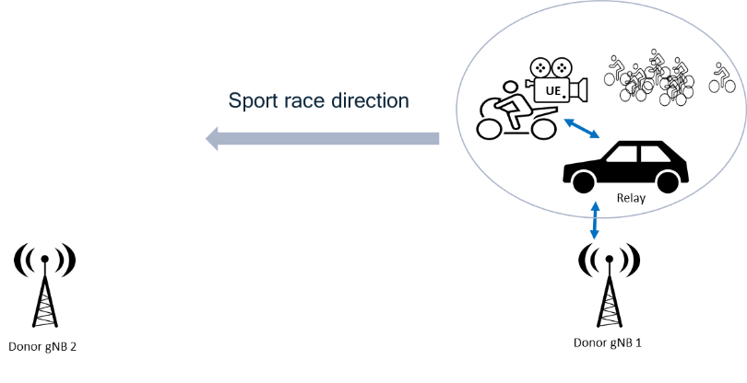

Fig. 5.19-1 Single radio link via mobile BS relay

In this scenario, depending on the radio conditions, required QoS, and available itinerary information, e.g. on number of vehicles with onboard relays planned to follow the race (maybe different in different parts of the itinerary), the network can decide to exploit simultaneous UE connectivity via two nearby mobile relays, if/when suitable.

### 5.19.2 Pre-conditions

5G UEs/cameras, and mobile BS relays mounted on vehicles, are provided by a local TV broadcaster, all pre-provisioned and configured to connect to a certain 5G PLMN network, with a sufficient RAN coverage for the mobile BS relays via dedicated donor RAN nodes covering the sport race itinerary. It is assumed that both relays and donor RAN nodes are part of the same PLMN.

### 5.19.3 Service Flows

1. The race is ongoing, and a certain UE (camera) is connected via one mobile BS relay mounted on a surrounding vehicle (from the TV broadcaster), as shown in figure 1.

2. After a while, e.g. when the road size get larger, a second vehicle, equipped with a mobile BS relay from the TV broadcaster, approaches the peloton and the UE.   
RAN, based on RF measurements, mobility configuration, or other available information (e,g, the identified additional vehicle will be within a close distance from the UE for a certain amount of time/itinerary), decides to add a simultaneous radio link, for that UE, via the second vehicle’s mobile relay .

The two simultaneous mobile relay links could be connected to the same or different donor RAN node, as illustrated below.

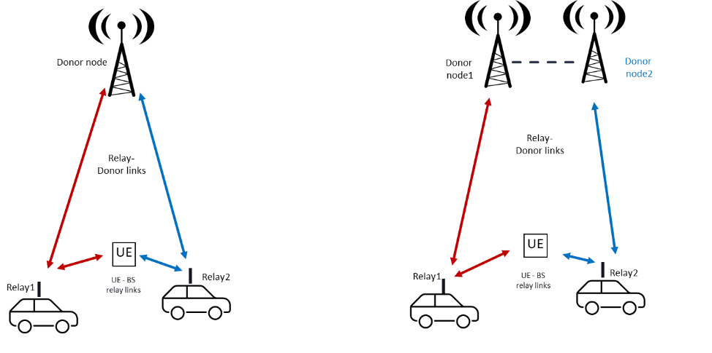

Fig. 5.19-2 Simultaneous radio links via multiple mobile BS relays

3. Later on, e.g. when the road gets narrower and/or one of the vehicles moves away from the UE, the RAN may remove the corresponding mobile BS relay link.

### 5.19.4 Post-conditions

UE connectivity and performance can exploit more robust and better performance using simultaneous mobile BS relay links, when multiple nearby vehicles are available.

### 5.19.5 Existing features partly or fully covering the use case functionality

Maybe partly covered by existing IAB, and related DC/CA functionalities, which do not assume full mobility of the relay nodes.

### 5.19.6 Potential New Requirements needed to support the use case

[PR 5.19-1] The 5G system shall be able to support simultaneous UE connectivity to RAN using multiple access links provided via different mobile base station relays (e.g. mounted on different vehicles).

NOTE 1: The above requirement covers scenarios were the UE access links (via the mobile BS relays) could be connected to the same or different RAN node(s), assuming both relay and donor RAN node(s) belong to the same PLMN,

NOTE 2: The above requirement includes supporting efficient addition and removal of a simultaneous access link via a mobile base station relay, while the UE is connected to the RAN via another mobile base station relay.

[PR 5.19-2] The 5G system shall be able to support, for a UE simultaneously connected to RAN via different mobile base station relays (e.g. mounted on vehicles), service continuity during various mobility events, e.g. when the connected mobile BS relays and/or the macro donor node(s) change.

## 5.20 Using a partner 5G network to transport vehicle relay traffic

### 5.20.1 Description

This use case covers certain deployment scenarios where traffic exchanged via vehicle relays for users of one MNO or service provider is carried over a transport 5G network managed by a second MNO. An example is illustrated in fig.1, where the MNO2 provides wireless access and transport between vehicle relays and the MNO1 5G network, allowing E2E connectivity to MNO1 users.

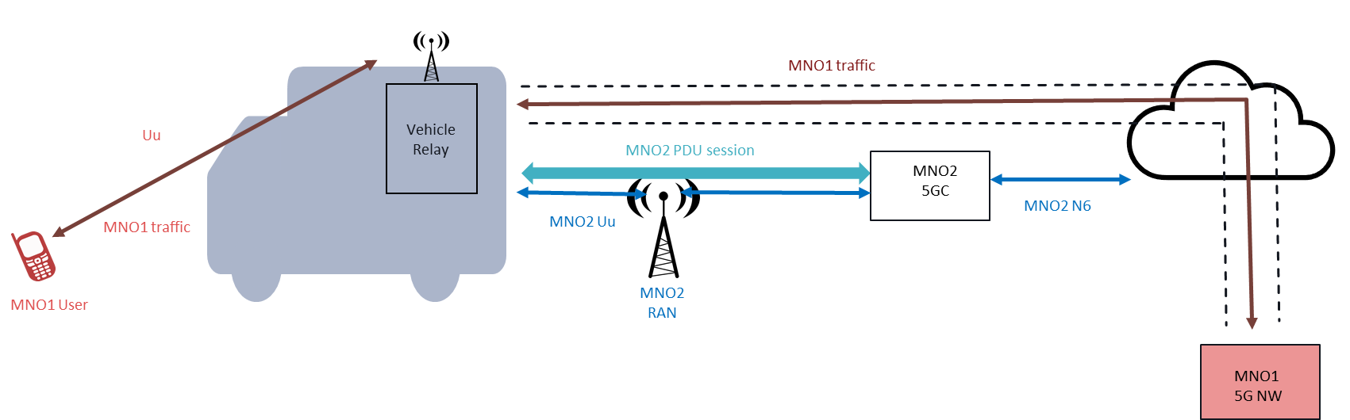

Fig 5.20-1: Example of mobile relays traffic from MNO-1 transported over MNO-2’s network.

Such scenarios can be based on business agreements among the two parties, specific NW deployment/operational constraints, coverage requirements, etc. For example, it could be used for:

* A 5G mobile operator (MNO1), with limited macro-RAN deployment and coverage footprint, willing to exploit their spectrum to offer 5G access and services to their subscribers (travelling in vehicles, or located in specific hotspot areas). MNO1 could decide to leverage the better/ubiquitous 5G wireless (and transport) connectivity provided by a second operator (MNO2) to tunnel the MNO1 traffic to/from the vehicle relays.
* Public Safety providers or other service/fleet operators, who could manage specific vehicles with on-board relays, together with ad-hoc 5G subscriptions and connectivity services for certain user categories, e.g. for first-responders, delivery personnel, public passengers etc. They may not necessarily own 5G spectrum, or RAN/network infrastructure, thus using MNO2’s mobile network to reach connectivity to their relays (and users).

### 5.20.2 Pre-conditions

For this use case, the following options are assumed:

* The access link between MNO1 UEs and the vehicle relay uses MNO1 spectrum; the relay can connect to the MNO2 RAN using MNO2 spectrum.
* The MNO2 transport connection, between the vehicle relay and the MNO1 network, is used to carry relay traffic between the vehicle relay and MNO1 5GC.

### 5.20.3 Service Flows

1. Vehicle relays are provisioned and configured to register to the MNO2 network and establish necessary PDU session(s), with certain quality of service and policies (as negotiated for MNO1 traffic and subscribers).

2. Vehicle relays are provisioned and configured to connect to the donor MNO1 network for communication between MNO1 users and MNO1 network.

3. MNO1 subscribers/UEs inside the vehicle camp on the mobile relays, which will broadcast MNO1 PLMN-ID, and are able to register and connect to the MNO1 network.

4. All traffic generated via vehicle relays by MNO1 UEs is tunnelled through the established relays’ MNO2 5G connectivity.

### 5.20.4 Post-conditions

MNO1 users can exploit their 5G service and the good in-vehicle 5G coverage/connectivity provided by the vehicle relays, fully transparently.

### 5.20.5 Existing features partly or fully covering the use case functionality

TS23.501 (Annex D) describes the concept of overlay network connection on top of underlay network connection, which does not fully cover the target use case and requirements, intended to be specific to mobile BS relays.

### 5.20.6 Potential New Requirements needed to support the use case

[PR 5.20-1] The 5G system shall be able to support communication from/to users of one MNO (MNO-A) via mobile vehicle base station relays, where the relayed traffic is transported to/from the MNO-A network using 5G connectivity (RAN and 5GC) provided by a different MNO (MNO-B).

NOTE 1: the above requirement includes support of necessary policies and provisioning for end-to-end user’s QoS, e.g. based on MNO-A user/UE’s subscription.

NOTE 2: the 5G transport and connectivity provided by the different MNO (MNO-B) assumes a generic wireless BS backhaul, independent from the BS relay functionalities.

## 5.21 Improved connectivity based on the relay mobility pattern

### 5.21.1 Description

Vehicles with onboard base stations, so called vehicle-mounted relays (VMR), are expected to act as relay and help provide efficient data delivery. This use case addresses the needs of users who are not moving with the vehicle-mounted relay but that can benefit from its offered connectivity when users and vehicle-mounted relays are close.

In particular, this use case addresses the needs of those UEs that either have limited connectivity (e.g., when connected to a macro cell) or that have too demanding bandwidth needs.

Our first use case is about a user, Tom, an emergency physician who just arrived at a car accident. Tom is attending several injured persons. Tom is having a call with other clinicians at a close-by hospital discussing the health state of the patients and to which hospital the patients should be transferred. Tom would also like to retrieve the Electronic Health Record (EHR) of the patients to do a better assessment. However, the network connectivity at his current location – the accident area -- is insufficient, in particular, to download some bulky files in the EHR of the patients. In this situation, it is beneficial if the 5G system can *schedule* the transfer of the EHR content requested by Tom so that the EHR is transferred by means of a relay mounted on one of the ambulances approaching the accident area. This example is shown in Figure x-1 where the ambulance is denoted AMR, i.e., Ambulance-Mounted Relay. In Figure x-1 Tom’s UE is denoted UE. At location L0 and time T0 the EHR data transfer is requested by the UE. The data is then transferred when the AMR is at location L2 since at this location the communication link between donor gNB and AMR and between AMR and UE offer the best end-to-end performance. The location is chosen by using, known or predicted, the AMR mobility pattern to optimize the network behaviour. In some cases, the AMR could receive the EHR data from the donor gNB at location L1 and time T1 and when the AMR is at location L3 at time T3, the AMR could rapidly deliver the requested EHR data to Tom’s UE. In this alternative approach, the locations L1 and L3 are chosen to optimize the individual link performance between donor gNB and AMR and between AMR and UE. The choice of these locations is also based on the known or predicted AMR mobility pattern.



Figure 5.21-1. Example scenario

Other relevant and related use cases include:

* IoT devices requiring the delivery of a software update. Some IoT devices might lack a good connection but be able to retrieve the software update from a vehicle-mounted relay, when it is close by.
* Users requiring access to bulky resources, e.g., a movie, but with insufficient connectivity at their current location. Users might retrieve the files from an approaching vehicle-mounted relay selected based on the mobility pattern of the VMR.

### 5.21.2 Pre-conditions

* An MNO operates AMRs and macro cells in a city.
* The user, Tom, has a UE and is subscribed to the MNO.
* The user, Tom, is connected to a macro base station and Tom needs to retrieve certain files.

### 5.21.3 Service Flows

* Tom is connected to the 5G macro network.
* Tom performs a call and tries to retrieve the EHR files of the patients.
* The 5G macro network is capable of delivering Tom’s normal communication needs, in particular, low bandwidth communication needs. The 5G macro network offers limited capacity for the download of large amounts of data due to spotty coverage and a high number of UEs at Tom’s location.
* The MNO operates AMRs that offer extra additional capacity. The mobile network determines that the download needs of our user Tom can be fulfilled by an AMR, an ambulance, approaching Tom’s location.
* The 5G system delivers the downlink traffic required by Tom to the ambulance that is approaching Tom’s location. The transfer of this EHR content to the ambulance and from the ambulance to Tom’s UE is done very fast since this is done where and when the communication links between macro gNB, AMR, and UE are expected to offer the best performance based on the known or predicted mobility pattern of the AMR.
* When the ambulance moves away, Tom’s UE releases its connection with the AMR.

### 5.21.4 Post-conditions

* Tom was able to retrieve the required EHR files in an efficient way so that he can attend the patients properly.

### 5.21.5 Existing features partly or fully covering the use case functionality

From Section 6.2.2 of TS 22.261: “*The 5G network shall allow operators to optimize network behaviour (e.g. mobility management support) based on the mobility patterns (e.g. stationary, nomadic, spatially restricted mobility, full mobility) of a UE or group of UEs*.” However, this requirement is not based on mobility information of vehicle-mounted relays.

Section 6.6 (Efficient content delivery) of TS 22.261 includes various requirements on efficient content delivery. However, these requirements are not based on mobility information of vehicle-mounted relays.

### 5.21.6 Potential New Requirements needed to support the use case

[PR 5.21-1] The 5G system shall be able to provide a means to optimize network behaviour to efficiently deliver data based on the mobility information (e.g., itinerary), known or predicted, of the vehicle-mounted relays.

## 5.22 Mobility between Non-terrestrial coverage and terrestrial coverage for Mobile Vehicular Relays

### 5.22.1 Description

In section 5.16, use case for Non-terrestrial coverage for Mobile Vehicular Relays has been specified.

In acutal 5G deployment, some areas could be covered by both non-terrestrial coverage and terrestrial coverage, and some area areas are only covered by either the non-terrestrial coverage and terrestrial coverage.

It could be good to support mobility of mobile vehicular relays between non-terrestrial coverage and terrestrial coverage

### 5.22.2 Pre-conditions

The following are assumed to be available for this use case:

- 5G non-terrestrial access is provided in a area A by a non-terrestrial platform (e.g. a LEO, MEO satellite) of one PLMN named O;

- 5G terrestrial access is provided in a area B by a terrestrial (fixed) base station of same PLMN O;

- 5G non-terrestrial and terrestrial access is provided in an area C, with is the overlapped area of A and B, by a terrestrial access of one PLMN;

- One vehicle named V equipped with 5G mobile BS relays, is able to obtain access from a non-terrestrial platform and a terrestrial access of one PLMN;

- The vehicle relays provide 5G access to UEs inside the vehicle and UEs nearby the vehicle (e.g. those UEs could be normal smartphones, without satellite capabilities.)

### 5.22.3 Service Flows

The vehicle V equipped with 5G mobile BS relays locates within area A, and connect via non-terrestrial access to PLMN O, and provide the 5G access to UEs inside the vehicle.

The vehicle V drive within area A but heading to area B, then it moves into area C where both 5G non-terrestrial access and terrestrial access are available.

Since vehicle V equipped with 5G mobile BS relays detected there is both 5G non-terrestrial access and terrestrial access, and based on some criteria the 5G mobile BS relays decides to using terrestrial access to connect to 5GC. The criteria includes operator policy, signal strength of the access and etc.



Figure 5.22-1: Vehicle Relays move from a non-terrestrial access area to terrestrial access area

During the “relay switch”, that is a period that 5G mobile BS relays switch from using the 5G non-terrestrial access to using the 5G terrestrial access to connect to 5GC, the 5G mobile BS relays continuing provide the 5G access to UEs inside the vehicle.

After this “relay switch”, the vehicle V equipped 5G mobile BS relays drives in area B and provide the 5G access to UEs inside the vehicle.

### 5.22.4 Post-conditions

The vehicle V equipped with 5G mobile BS relays using 5G terrestrial access connect to 5GC, and provide the 5G access to UEs inside the vehicle.

### 5.22.5 Existing features partly or fully covering the use case functionality

Current stage-1 requirements (e.g. on wireless self-backhaul, in TS 22.261), as well as existing stage-2/3 functionalities and architecture options (e.g. IAB) do not assume or address full relay mobility (e.g. BS relays on board of moving vehicles), thus may not cover the identified new potential requirements, which are intended to be specific to mobile BS relays.

### 5.22.6 Potential New Requirements needed to support the use case

[PR 5.22.6-1] The 5G System shall be able to support mobile base station relays using NR satellite access and using NR terrestrial access to connect to 5GC.

[PR 5.22.6-2] The 5G System shall be able to support a mobile base station relay capable using both NR satellite access and NR terrestrial access with service continuity in the scenario when this mobile base station relay switch from using NR satellite access to using NR terrestrial access, and vice versa.

## 5.23 Mobile Vehicular Relays using Non-terrestrial and terrestrial access simultaneously

### 5.23.1 Description

In section 5.16, use case for Non-terrestrial coverage for Mobile Vehicular Relays has been specified.

In actual 5G deployment, some areas could be covered by both non-terrestrial coverage and terrestrial coverage.

It could be good to support of mobile vehicular relays using non-terrestrial access and terrestrial access simultaneously to connect to 5GC.

### 5.23.2 Pre-conditions

The following are assumed to be available for this use case:

- 5G non-terrestrial access is provided in an area A by a non-terrestrial platform (e.g. a LEO, MEO satellite) of one PLMN named O;

- 5G terrestrial access is provided in an area B by a terrestrial (fixed) base station of same PLMN O;

- Area A and area B are largely overlapped;

- One vehicle named X equipped with 5G mobile BS relays, is able to using access from a non-terrestrial platform and a terrestrial access at same time;

- The vehicle relays provide 5G access to UEs inside the vehicle and UEs nearby the vehicle (e.g. those UEs could be normal smartphones, without satellite capabilities.)

### 5.23.3 Service Flows

The vehicle X equipped with 5G mobile BS relay locates within area A, it detects the access could be used to 5GC. Then it decides to connect via terrestrial access to PLMN O. Once successes, it then provide the 5G access to UEs inside the vehicle.

Due to some reasons, e.g. UE amounts accesses increase, huge demand of bandwidth, the vehicle X find that total bandwidth of current relay link could not meet above demands, and then vehicle X decides to use the non-terrestrial access as relay link.

The vehicle X then detect whether there is non-terrestrial access coverage. If yes, the vehicle X equipped with 5G mobile BS relay connect to the PLMN O. If it is authorised to provide 5G access to UEs, then more UEs and more bandwidths requirements could be meet. That is, more and more UE could access the network via this vehicle X equipped with 5G mobile BS.

The vehicle X equipped with 5G mobile BS monitors the usage of the relay link, and once the service demand decrease, it then decides to dis-connect one relay link, e.g. it dis-connect the terrestrial access link.

The vehicle X also monitors the radio coverage. For example, if there is no terrestrial access available, or the radio conditions of terrestrial access deteriorates, the vehicle X has no choice but to dis-connect the terrestrial access link



Figure 5.23-1: Vehicle Relays using non-terrestrial access and terrestrial access simultaneously

### 5.23.4 Post-conditions

The vehicle X equipped with 5G mobile BS relays using both 5G terrestrial access and non-terrestrial access connect to 5GC, and provide the 5G access to UEs inside the vehicle and UEs nearby the vehicle (e.g. those UEs could be normal smartphones, without satellite capabilities).

### 5.23.5 Existing features partly or fully covering the use case functionality

Current stage-1 requirements (e.g. on wireless self-backhaul, in TS 22.261), as well as existing stage-2/3 functionalities and architecture options (e.g. IAB) do not assume or address full relay mobility (e.g. BS relays on board of moving vehicles), thus may not cover the identified new potential requirements, which are intended to be specific to mobile BS relays.

### 5.23.6 Potential New Requirements needed to support the use case

[PR 5.23.6-1] The 5G System shall be able to support mobile base station relays capable of connecting via both NR satellite access and NR terrestrial access, to select one access as a relay link between the mobile base station relays and the 5GC.

[PR 5.23.6-2] The 5G System shall be able to support mobile base station relays capable of connecting simultaneously via NR satellite access and NR terrestrial access as relay link to connect via both to 5GC at the same time.

[PR 5.23.6-3] The 5G System shall be able to support mobile base station relays capable of connecting in parallel via NR satellite and NR terrestrial access to add a second relay link to allow more UEs to access the network and e.g. to adapt to increased bandwidths demand for access via this mobile base station relay.

[PR 5.23.6-4] The 5G System shall be able to support mobile base station relays connected via both NR satellite and NR terrestrial access to remove one of two relay links to adapt to decreased bandwidths demand of UEs accessing via this mobile base station relay.

[PR 5.23.6-5] The 5G System shall be able to support mobile relay traffic load balancing across satellite and terrestrial access links, for mobile base station relays that use both NR satellite access and NR terrestrial access as relay link at the same time.

Note 1: The simultaneous satellite and terrestrial access links (from the relay) are assumed to carry traffic pertaining to different UEs.

# 6 Other considerations

This section includes other aspects of mobile vehicle relays deployments and potential service requirements, not specifically covered by the use cases and requirements described in the section 5, particularly related to:

* The possibility for a relay to have a HPLMN subscription, and roam into other networks, together with the need to have proper control from both home and visited PLMNs;
* The need to potentially support regulatory requirements, including emergency services;
* The ability to support priority services, such as MPS;
* The expected support of end-to-end security;
* The ability to avoid or overcome challenges related to radio interference.

Corresponding new potential service requirements are captured below.

[PR 6-1a] The 5G System shall support means for a mobile base station relay to have a subscription with a HPLMN, used to get access and connectivity to the HPLMN 5GC (via a donor RAN).

[PR 6-1b] The 5G System shall support the ability of a base station relay to roam from its HPLMN into a VPLMN.

[PR 6-1c] The 5G system shall support mechanisms, for the HPLMN controlling a mobile base station relay, to enable/disable mobile relay operation if/when the relay (e.g. on a mobile vehicle) is roaming in a VPLMN.

[PR 6-1d] The 5G system shall support mechanisms to disable mobile relay operation by VPLMN where a mobile base station relay is roaming to.

[PR 6-2] The 5G system shall be able to fulfil necessary regulatory requirements (e.g. for support of emergency services) when UEs access the 3GPP network via a mobile base station relay.

[PR 6-3] The 5G system shall be able to support priority services (e.g. MPS) when UEs access the 3GPP network via a mobile base station relay.

[PR 6-4] The 5G system shall ensure that end-to-end 5G security between the UE and 3GPP network is supported when the UE accesses the 3GPP network via a mobile base station relay.

[PR 6-5] The 5G system shall be able to minimize radio interference possibly caused by mobile base station relays (e.g. when mounted on moving vehicles).

# 7 Potential Consolidated Requirements

## 7.0 Introduction

The requirements below refer to a “*mobile base station relay”* (or mobile BS relay), which is a mobile base station acting as a relay between a UE and the 5G network, i.e. providing a NR access link to UEs and connected wirelessly (using NR) through a donor NG-RAN to the 5G Core. Such mobile BS relay is assumed to be mounted on a moving vehicle and serve UEs that can be located inside or outside the vehicle (or entering/leaving the vehicle).

NOTE: the radio link used between a mobile BS relay and served UEs, as well as between mobile BS relay and donor RAN, is assumed to be NR-Uu; in that regard, it should be clear that a mobile BS relay is different than a UE relay (which uses instead a PC5-based link to provide indirect connection to remote UEs).

Few main underlying assumptions and notes (from the TR overview and gap analysis) are:

- use cases and requirements cover single-hop relay scenarios as baseline (multi-hop is not precluded);

- legacy UEs are supported;

- current stage-1 requirements (e.g. on wireless self-backhaul, in TS 22.261), as well as existing stage-2/3 functionalities and architecture options (e.g. IAB) do not assume or address full relay mobility (e.g. BS relays on board of moving vehicles), thus may not cover the identified new potential requirements, which are intended to be specific to mobile BS relays;

- The identified requirements do not intend to imply or exclude specific network/relay architectures and topology solutions (e.g. could be IAB based, or others).

## 7.1 General requirements

**Table 7.1-1 – General Consolidated Requirements**

| **CPR #** | **Consolidated Potential Requirement** | **Original PR #** | **Comment** |
| --- | --- | --- | --- |
| CPR 7.1-1 | The 5G system shall support efficient operation of mobile base station relays. | PR 5.1-1, 5.3-1, 5.6-1, 5.8-1 |  |
| CPR 7.1-2 | The 5G system shall be able to support means, for a mobile network operator, to configure, provision and control the operation of a mobile base station relay, e.g. activation/deactivation, permitted location(s) or time of operation. | PR 5.1-2, 5.2-2, 5.2-3 |  |
| CPR 7.1-3 | The 5G system shall be able to support provisioning and configuration mechanisms to control UEs’ selection and access to a mobile base station relay, e.g. based on UE’s authorization, geographic or temporary restrictions, relay’s load | PR 5.2-1, 5.4-1, 5.3-2, 5.5-1 |  |
| CPR 7.1-4 | The 5G System shall be able to support mobile base station relays using 3GPP satellite NG-RAN. | PR 5.16.6-1 |  |
| CPR 7.1-5 | The 5G system shall be able to support RAN sharing between multiple PLMNs for UEs connected to the 5G network via mobile base station relays.  NOTE 1: the above requirement assumes both relay and (donor) RAN resources, including UE access link and relay backhaul link, are shared among operators | PR 5.17-1 |  |
| CPR 7.1-6 | The 5G system shall be able to configure and provision specific required QoS for traffic relayed via a mobile base station relay.  NOTE 2: QoS is end-to-end, i.e. from UE to 5GC. | PR 5.10-1 |  |
| CPR 7.1-7 | Subject to regulatory requirements and based on operator policy, the 5G system shall support means to configure and expose monitoring information of a mobile base station relay to an MNO’s authorized third-party. | PR 5.18-1 |  |
| CPR 7.1-8 | The 5G system shall be able to support incremental deployment of connectivity by means of one or a series of mobile base station relays for use only in specific locations where UEs would receive no other 3GPP access (terrestrial or non-terrestrial) coverage, e.g., for public safety scenarios. | PR 5.15.6-1 |  |
| CPR 7.1-9 | The 5G system shall be able to provide means to optimize network behaviour to efficiently deliver data based on the mobility information (e.g., itinerary), known or predicted, of mobile base station relays. | PR 5.21-1 |  |
| CPR 7.1-10 | The 5G system shall be able to support communication from/to users of one MNO (MNO-A) via mobile base station relays, where the traffic between the relay and the MNO-A network is transported using 5G connectivity (RAN and 5GC) provided by a different MNO (MNO-B).  NOTE 3: The 5G connectivity provided to the MNO-A relays by the different MNO (MNO-B) assumes a generic wireless backhaul transport, independent from the mobile BS relay functionalities. | PR 5.20-1 |  |

## 7.2 Multi-link connectivity

**Table 7.2-1 – Multi-link connectivity Consolidated Requirements**

| **CPR #** | **Consolidated Potential Requirement** | **Original PR #** | **Comment** |
| --- | --- | --- | --- |
| CPR 7.2-1 | The 5G system shall be able to supportUEs connectivity to RAN using simultaneously, a link without mobile BS relay and a linkvia a mobile BS relay, or simultaneous links via different mobile BS relays.  NOTE 4: the above requirements cover scenarios were the two links (to the RAN) could be connected to the same or different RAN node(s), and assuming both relay and RAN belong to the same PLMN. | PR 5.13.6-2, 5.19-1 |  |
| CPR 7.2-2 | The 5G system shall be able to support mobile base station relays accessing to 5GC via NR satellite access and NR terrestrial access simultaneously. | PR 5.22.6-1, 5.23.6-1/2/3/4/5 |  |

## 7.3 Mobility

**Table 7.3-1 – Mobility Consolidated Requirements**

| **CPR #** | **Consolidated Potential Requirement** | **Original PR #** | **Comment** |
| --- | --- | --- | --- |
| CPR 7.3-1 | The 5G system shall be able to provide means to support efficient UE cell selection and cell reselection (between mobile BS relays or between relays and RAN) in the presence of mobile base station relays. | PR 5.7-1, 5.12.6-1, 5.13.6-1 |  |
| CPR 7.3-2 | The 5G system shall be able to support mechanisms to optimize mobility and energy efficiency for UEs located in a vehicle equipped with a base station relay.  NOTE 4a: The above requirements cover scenarios where mobile base station relays provide 5G access for both UEs in the vehicle and around the vehicle. | PR 5.14.6-1 |  |
| CPR 7.3-3 | The 5G system shall be able to ensure end-to-end service continuity, in the presence of mobile base station relays  NOTE 5: the above requirement intends to cover different scenarios of UE mobility (e.g. UE moving between two mobile BS relays, or between macro RAN and BS relay) and BS relay mobility (e.g. BS relay moving between different donor RAN nodes). | PR 5.7-2, 5.6-2, 5.11.1-1/2, 5.11.2-1/2, 5.11.3-1/2, 5.11.4-1, 5.13.6-1, 5.17-2, 5.19-2 |  |
| CPR 7.3-4 | The 5G System shall be able to support service continuity for mobile base station relays using at least one 3GPP satellite NG-RAN.  NOTE 6: This requirement applies to scenarios where there is a transition between two 3GPP NG-RAN, operated by the same MNO, involving at least one 3GPP satellite NG-RAN. | PR 5.16.6-2, 5.22.6-2 |  |

## 7.4 Charging

**Table 7.4-1 – Charging Consolidated Requirements**

| **CPR #** | **Consolidated Potential Requirement** | **Original PR #** | **Comment** |
| --- | --- | --- | --- |
| CPR 7.4-1 | The 5G system shall be able to identify and differentiate UEs’ traffic carried via a mobile base station relay and collect charging information, including specific relay information (e.g. geographic location served by the relay). | PR 5.10-2, 5.10-3, 5.10-4 |  |

## 7.5 Other aspects

**Table 7.5-1 – Other Consolidated Requirements**

| **CPR #** | **Consolidated Potential Requirement** | **Original PR #** | **Comment** |
| --- | --- | --- | --- |
| CPR 7.5-1 | The 5G System shall support means for a mobile base station relay to have a certain subscription with a HPLMN, used to get access and connectivity to the HPLMN network (via a donor RAN). | PR 6-1a |  |
| CPR 7.5-2 | The 5G System shall support the ability of a base station relay to roam from its HPLMN into a VPLMN. | PR 6-1b |  |
| CPR 7.5-3 | The 5G system shall support mechanisms, for the HPLMN controlling a mobile base station relay, to enable/disable mobile relay operation if the relay is roaming in a VPLMN. | PR 6-1c |  |
| CPR 7.5-4 | The 5G system shall support mechanisms to disable mobile relay operation by a VPLMN where a mobile base station relay is roaming to | PR 6-1d |  |
| CPR 7.5-5 | The 5G system shall be able to fulfil necessary regulatory requirements (e.g. for support of emergency services) when UEs access the 3GPP network via a mobile base station relay. | PR 6-2 |  |
| CPR 7.5-6 | The 5G system shall be able to support priority services (e.g. MPS) when UEs access the 3GPP network via a mobile base station relay. | PR 6-3 |  |
| CPR 7.5-7 | The 5G system shall be able to support location services for the UEs accessing 5GS via a mobile base station relay. | PR 5.9-1, 5.9-2 |  |
| CPR 7.5-8 | The 5G system shall ensure that existing end-to-end 5G security between the UE and 3GPP network is unaffected when the UE accesses the 3GPP network via a mobile base station relay. | PR 6-4 |  |
| CPR 7.5-9 | The 5G system shall be able to minimize radio interference possibly caused by mobile base station relays. | PR 6-5 |  |
| CPR 7.5-10 | The 5G system shall minimize the impact of the presence of mobile base station relays on radio network management (e.g. through automatic neighbour cell list configuration). | N.A | Added during consolidation |

# 8 Conclusions and Recommendations

This technical report identifies several use cases and potential new requirements for 5GS support of mobile base station relays. The resulting service requirements have been consolidated in clause 7.

It is recommended to consider the consolidated requirements identified in this TR as the baseline for subsequent normative work.

Annex A:  
Change history

|  |  |  |  |  |  |  |  |
| --- | --- | --- | --- | --- | --- | --- | --- |
| **Change history** | | | | | | | |
| **Date** | **Meeting** | **TDoc** | **CR** | **Rev** | **Cat** | **Subject/Comment** | **New version** |
| 2020-11 | SA1#92e | S1-204244 |  |  |  | TR skeleton | 0.0.0 |
| 2020-11 | SA1#92e | S1-204362 |  |  |  | Version incorporating use cases and inputs agreed at S1-92e | 0.1.0 |
| 2021-03 | SA1#93e | S1-210316 |  |  |  | Version incorporating use cases and inputs agreed at S1-93e | 0.2.0 |
| 2021-05 | SA1#94e | S1-211312 |  |  |  | Version incorporating use cases and inputs agreed at S1-94e | 0.3.0 |
| 2021-06 | SA#92e | SP-210515 |  |  |  | Raised to v.1.0.0 for presentation for information | 1.0.0 |
| 2021-07 | SA1#94bis | S1-212100 |  |  |  | Version incorporating use cases and inputs agreed at S1-94e-BIS | 1.1.0 |
| 2021-08 | SA1#95e | S1-213200 |  |  |  | Version incorporating use cases and inputs agreed at S1-95e | 1.2.0 |
| 2021-09 | SA#93e | SP211048 |  |  |  | Raised to v.2.0.0 for presentation for approval | 2.0.0 |
| 2021-09 | SA#93e | SP211048 |  |  |  | Raised to v.18.0.0 following SA#93e's approval | 18.0.0 |
| 2021-12 | SP-94 | SP-211496 | 0001 |  | D | CPR Mapping | 18.1.0 |